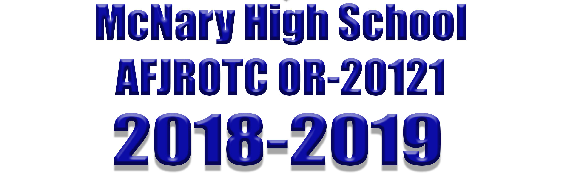

CADET GUIDE

McNARY HIGH SCHOOL
AIR FORCE JUNIOR ROTC
OR-20121 – SKY HIGH!!

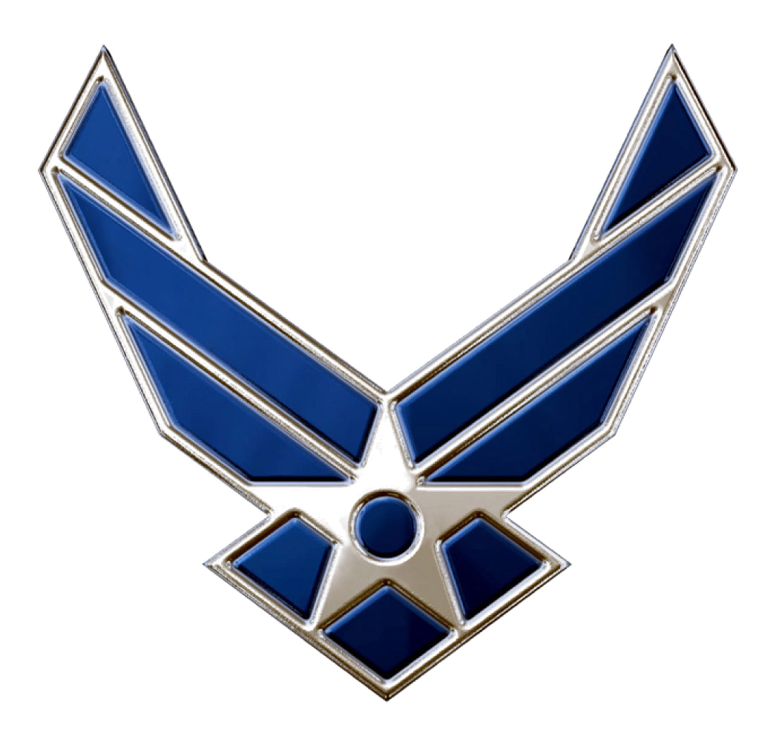

THE CADET HONOR CODE

"I WILL NOT LIE, CHEAT OR STEAL, NOR WILL I TOLERATE THOSE AMONG US WHO DO."

THIS IS THE MOST IMPORTANT STATEMENT IN THIS HANDBOOK! THINK IT OVER, REREAD IT, AND BE SURE YOU UNDERSTAND IT, AND LIVE BY IT!

These simple words provide the basis for a personal code of ethics that will last the remainder of your life. The honor code is specific and clear in what it demands. A cadet is expected to be trustworthy and to have complete integrity in both word and deed. Trustworthiness is an attribute based on character; what you are as a person. To be trustworthy means to be dependable, that others can count on you to do what is right because it is right. Cadets avoid unnecessary arguing or evasive statements; they do their own work in class, yet are willing to assist others in a sense of cooperation in reaching common goals. This requires self-control and a conscientious effort at all times. Eventually, it becomes an ingrained habit and part of your total life-style.

UNITED STATES AIR FORCE MISSION STATEMENT

Deliver sovereign options for the defense of the United States of America and its global interest, to fly and fight in Air, Space and Cyberspace.

UNITED STATES AIR FORCE CORE VALUES

INTEGRITY FIRST

-It is the willingness to do what is right even
when no one is looking

SERVICE BEFORE SELF

-Professional duties take precedence over
personal desires

EXCELLENCE IN ALL WE DO

-To develop a sustained passion for
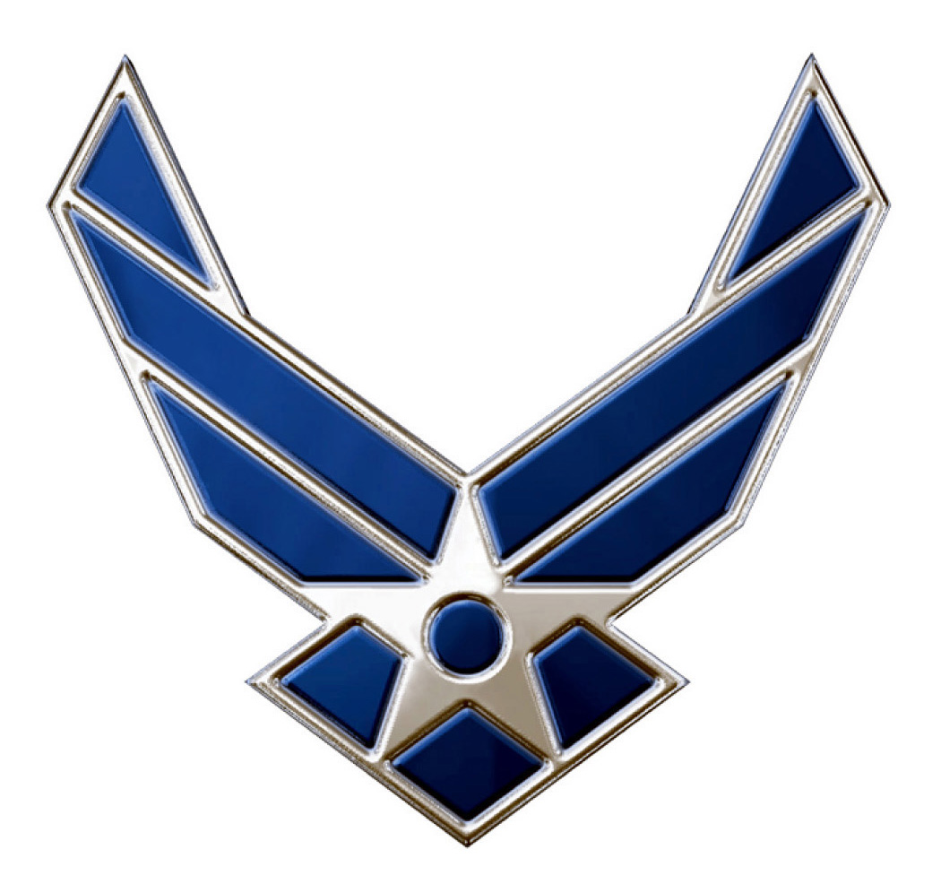
continuous improvement

McNARY HIGH SCHOOL
CADET HANDBOOK

TABLE OF CONTENTS

Page
THE CADET HONOR CODE 2
US AIR FORCE CORE VALUES 3
TABLE OF CONTENTS 4 FOREWORD 6
SUMMARY OF CHANGE 7
MISSION 8
OBJECTIVES 9

CHAPTER 1 - GENERAL

1-1. Purpose and Designation 10
1-2. Enrollment Eligibility 10
1-3. Disenrollment 10
1-4. Course Curriculum 11
1-5. High School Credit Towards Graduation 11
1-6. Certificates of Completion/Training Certificates 11
1-7. Unit Organization 11
1-8. Cadet Appointment and Rotation 11
1-9. Cadet Rank and Promotion 12
1-10. Officer/NCO Termination from a Command or Staff Position 13

CHAPTER 2 - DEPORTMENT

2-1. General 14
2-2. Command and Staff 14
2-3. Public Display of Affection (PDA) 15
2-4. Cadet Relationships…………………………………………………………. 15
2-5. Dress Code 15
2-6. Hazing 16
2-7. AFJROTC Area and Classroom Procedures 16
2-8. Books and Assignments 18
2-9. The Military Salute 18
2-10. Reporting Procedures……………………………………………………...…20
2-11. Discipline …………………………..……………………………………..…..20
2-12. Board of Inquiry……………………………………………………………….20

CHAPTER 3 - THE AIR FORCE JUNIOR ROTC UNIFORM

3-1. Concept 21
3-2. Wear of Uniform 22
3-3. Uniform and Materials Accountability 23
3-4. Removal of Service Dress Coat 24
3-5. Wear of Cap/Hat/Beret 24
3-6. Distinctive Uniform Items 24
3-7. Optional Uniform Items 27
3-8. Hair Standards 26 3-9. Enforcement 26
3-10 PT (Physical Training) Uniform Wear .……………………………………29

CHAPTER 4 - GRADING PROCEDURES

4-1. General 30
4-2. Aerospace Science (AS) Syllabus and Grading Procedures 30
4-3. Leadership Education (LE) Syllabus and Grading Procedures 32
4-4 JROTC Cadet Leadership Course (CLC) AS 41 33
4-5 Joint Spring Leadership Camps ………..………………………………….34

CHAPTER 5 - CADET BOARDS AND STAFF MEETINGS

5-1. Purpose 33
5-2. Responsibilities/Recommendations 33
5-3. Staff Meetings 34

CHAPTER 6 - SPECIAL ACTIVITIES

6-1. Purpose……………………………………..…………………………………34
6-2. Flag Detail……………………………………..………………………………34
6-3. Color Guard 35
6-4. Knights Drill Team 35
6-5. Physical Training (PT) Team...……………….……………………………. 35
6-6. Oregon High School Athletics Association (HHSAA) bylaws……...……..35
6-7. Awareness Presentation Team (APT)……………………………………...35
6-8. Rocket/Model Club………………………………..…………………………..36
6-9. Group Newsletter .36
6-10. Flights in Air Force Aircraft……………………….………………..………...36
6-11. Other Field Trips……………………………………………………………....36
6-12. Military Ball……………………………………………………………………..37
6-13. Dining-In………………………………………………………………………..37
6-14. Kitty Hawk Air Society (KHAS)………………………………………………37
6-15. Community Service ……………………………………………………….....37
6-16. Other Activities………………………………………………………………..38
6-17. Participation of Non-Cadets 48
6-17. Basic Cadet Induction ………………………………………..……………..48
6-18. Activity Fees 48

CHAPTER 7 - AWARDS AND DECORATIONS

7-1. Concept 38
7-2. AFJROTC Award Procedures 39
7-3. Cadet of the Month 39
7-4. Service Ribbon 53

CHAPTER 8 - CAREER PLANNING AND PREPARATION

8-1. Concept 54
8-2. Service Academy Appointments 54
8-3. College ROTC Scholarships 54
8-4. AFJROTC Scholarships 54
8-5. Service Enlistment 54
8-6. Armed Services Vocational Aptitude Battery Test 54

ATTACHMENTS …………………………………………………………..…………………..55

1. UNIT MANNING DOCUMENT ………………………………………………....56 2. JOB DESCRIPTIONS……………………….…………………..……………….57
3. COMPUTER PROCEDURES……………………..…………………………….64
4. CADET STAFF AREA AND CLASSROOM PROCEDURES………………..65
5. CADET OF THE MONTH/SEMESTER……………………..………………….66
6. BULLETIN BOARDS AND TV DISPLAYS……………………..………………67
7. AIR FORCE JUNIOR ROTC INSIGNIAS……………………..……………….68
8. AIR FORCE JUNIOR ROTC BADGES……………………..………………….69
9. CADET MALE BLUE SHIRT……………………..…………………..………….70
10. CADET FEMALE BLUE SHIRT……………………..…………….…………….71
11. CADET MALE 1620 SERVICE DRESS……………………..………………….72
12. CADET FEMALE 1620 SERVICE DRESS……………………..………………73
13. CADET MALE HEADGEAR……………………..……………………………….74
14. CADET FEMALE HEADGEAR……………………..………………...………….75
15. CADET AIRMAN BATTLE UNIFORM (ABU) ……………………..…………...76
16. WINDSOR TIE KNOT (RIGHT) ……………………..………………….……….77
17. FOUR-IN-HAND TIE KNOT……………………..…………………………….….78
18. UNIFORM REPLACEMENT PRICE LIST……………………………………….79
19. JROTC RIBBON CHART……………………..……………………………….….80
20. UNITED STATES ARMED FORCES ENLISTED RANKS………………….…81
21. UNITED STATES ARMED FORCES OFFICER RANKS……………………...82
22. 30 STEP DRILL PROCEDURE…………………………………………………..83

AIR FORCE JUNIOR ROTC OR-20121
McNARY HIGH SCHOOL

595 Chemawa Rd. N.
Keizer, OR 97303

FOREWORD

Air Force Junior Reserve Officer Training Corps (AFJROTC) at McNary High School will give you an opportunity to develop skills and achieve a potential you never thought you had. JROTC provides an opportunity to learn and apply leadership techniques, develop character and self-discipline, and study aerospace fundamentals. Confidence in your ability to lead and assume responsibility has universal applications in civilian life as well as in the military. To some, leadership seems to come naturally; others only learn through disciplined practice. Everyone finds it is harder than they thought. But it's rewarding and satisfying when the element, flight, Squadron or group you are leading achieves it’s goal and you were responsible for leading them there.

You do not have to have rank to lead. Rank or prior experience alone does not make a leader. A few cadets refuse to lead anything, and a few refuse to participate in anything unless they can lead. Both types are equally ineffective in an organization. We urge you to avoid these extremes, learn all you can from the AFJROTC experience, and apply that knowledge for your betterment, that of your fellow AFJROTC members, your school, and the community. You may even be called upon to represent AFJROTC and the Air Force in the community. Always uphold this obligation and wear the uniform proudly and correctly.

Academic performance in the Aerospace Science and Leadership curriculum should balance out your efforts in AFJROTC. Every effort is made to make the program interesting, enjoyable, and a positive learning experience. Success depends on each cadet’s regular attendance, positive attitude, and willingness to work diligently and responsibly. Each cadet can be assured of a successful academic year in AFJROTC by following these simple guidelines.

AFJROTC also provides practice in military drill and ceremony, flights on Air Force aircraft, and numerous worthwhile field trips. There are various teams and clubs available for AFJROTC cadets that allow members of the corps to earn school letters. Finally, scholarship opportunities and advanced rank await those who elect to join a branch of the armed forces.

It is with great pride that McNary High School offers AFJROTC, and you are to be commended on your selection of this course.

SUMMARY OF CHANGES

This handbook supersedes the previous McNary High School AFJROTC Cadet Handbook, dated 2017-2018. This new edition incorporates updated guidance from various Air Force and JROTC directives, changes several corps leadership job descriptions, revises the organizational chart, and corrects minor administrative errors.

This handbook is a “living” document, continually improving with the input of cadets, instructors, and active duty Air Force directives and guidance from AFROTC Headquarters and ROTC regional personnel.

Suggestions for changes and improvements should be addressed in writing to the McNary High School AFJROTC instructors. Clearly identify the section(s) to be changed and provide a rationale for the change.

DISTRIBUTION:

Senior Aerospace Science Instructor 1
Aerospace Science Instructor 1
McNary HS PRINCIPAL 1
CADETS (EACH) 1


McNary HS MISSION STATEMENT

“Bold enough to be the best at educating, nurturing, and inspiring”

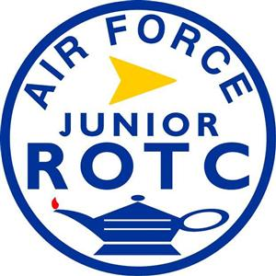
AFJROTC MISSION:

“DEVELOP CITIZENS OF CHARACTER DEDICATED TO SERVING THEIR NATION AND COMMUNITY”

GOALS & OBJECTIVES

- The goals of the AFJROTC program are to instill the following in high school cadets:

* Values of citizenship * Service to the United States

* Personal responsibility * Sense of accomplishment

- The objectives of the AFJROTC program are to educate and train high school cadets in citizenship; promote community service; instill responsibility, character, and self-discipline; and provide instruction in air and space fundamentals.

- With these objectives the cadets will develop:

- Respect for and understanding of the need for constituted authority in a democratic society.

- Patriotism and an understanding of their personal obligation to contribute to national security.

- Habits of orderliness and precision.

- A high degree of personal honor, self-reliance, and leadership.

- Broad-base knowledge of the aerospace age and fundamental aerospace doctrine.

- Basic military skills.

- A knowledge and appreciation for the traditions of the Air Force.

An interest in completing high school and pursuing higher educational goals and skills

An understanding of the Air Force and military service as a possible career path.

CHAPTER 1 - GENERAL

1-1. Purpose and Designation

a. This handbook provides guidance and establishes procedures/standards of performance for the organization and operation of the Cadet Corps of the AFJROTC unit at McNary High School (MHS). The handbook serves as a reference for cadet appearance and deportment, wear of the uniform, academic policies, classroom procedures, and other important procedural and operational items. The procedures and standards found in this handbook will help each cadet to develop character, discipline, respect for self and others, pride in achievement, and life-long learning skills.

b. These procedures come from multiple sources including the US Public Law (Public Law 88-647, Chapter 102) authorizing and establishing the AFJROTC program, the agreement between McNary High School and the United States Air Force (USAF), directives prepared by the USAF ROTC Headquarters, and from experience gained at this and various other AFJROTC units worldwide.

c. Our official USAF designation: OR-20121 (Unit opened as first Oregon AFJROTC unit to be established in 2012).

1-2. Enrollment Eligibility

a. Enrollment eligibility is found in AFJROTCI 36-2010, paragraph 2.1 and 2.4.

b. Student’s transferring from other AFJROTC units may be given credit for training received upon presentation of documentation from their previous unit. See AFJROTCI 36-2010, paragraph 2.2.4

c. Reserve Cadet. A Reserve Cadet is a student who either 1) completed the entire AFJROTC Academic Program, 2) is in a 4x4 schedule and completed an AFJROTC course during one term, but is not participating in an AFJROTC course during the current term, or 3) is in a traditional schedule unit where the cadet cannot participate in the AFJROTC academic program for that particular year. A student must have been a cadet for at least one academic year (academic term for 4x4) prior to being considered a Reserve Cadet. Reserve cadets may participate in all AFJROTC activities (community service, drill, color guard, etc), see AFJROTCI 36-2010, paragraph 7.1.4-7.1.4.5 for a complete definition of a reserve cadet.

1-3. Disenrollment

AFJROTC students may be disenrolled at any time during the academic year with proper cause in accordance with AFJROTC 36-2010, 2.4.1.1.3. This should be a last resort, preceded by substantiated documentation and corrective counseling, to maintain the morale and discipline of the unit. A student may be disenrolled for:

- Failure to maintain acceptable standards (including uniform wear and grooming).
- Inaptitude or indifference to training.
- Disciplinary reasons.
- Any other reason deemed appropriate by the AFJROTC SASI and the principal.

1-4. Course Curriculum

The AFJROTC program normally consists of the courses named below. A detailed curriculum description may be found in ASI’s Office.

a. TJA1000: Journey into Aviation History and Leadership Education I.

b. TJA2000: The Science of Flight and Leadership Education II.

c. TJA3000: The Exploration of Space and Leadership Education III.

d. TJA4000: Management of the Cadet Corps and Leadership Education IV.

1-5. High School Credit Towards Graduation

The McNary Public Schools Course Description Catalog provides the specific AFJROTC course descriptions and defines the JROTC credits that may be applied towards graduation requirements.

1-6. Certificates of Completion/Training Certificates (AFJROTCI 36-2001, paragraph 10.2)

a. AFOATS Form 310, Certificate of Completion. An AFJROTC Certificate of Completion is presented to each cadet who successfully completes two or more years of the program.

1-7. Unit Organization

AFJROTCI 36-2010 defines the organizational structure of AFJROTC units. Attachments 1 and 2 to this handbook establish OR-20121's Unit Manning Document (UMD) and job descriptions.

1-8. Cadet Appointment and Rotation

The SASI and the ASI, will select the Cadet Command Staff (CCS). The CCS consists of the Cadet Group Commander, Cadet Special Assistant to the SASI, Cadet Inspector General, Cadet Operations Squadron Commander (serves also as the Cadet Operations Vice-Group Commander when Cadet Group Commander is absent), Cadet Mission Support Squadron Commander, Cadet Services Squadron Commander, Cadet Logistics Squadron Commander, Cadet Recruiting Squadron Commander, Cadet Kitty Hawk Air Society Commander, Cadet Group First Sergeant, Flight Commanders, Athletics Officer, and the Public Affairs Officer.

a. Selection to a command or staff position will be based on demonstrated leadership, academic performance, military behavior, and the individual's desire and potential to fulfill the demands of the position.

b. Cadet Command Staff(CCS) officers will normally serve one semester. Earlier rotation of cadet assignments may be made to provide leadership experience for a larger number of cadets. Flight Commanders will serve one quarter.

c. Some selected officers on staff positions during the first semester may be appointed to advisory or special assistant status for the second semester.

d. Proposed vacancies will be made known to each flight and the group staff. Candidates interested in a position may apply for that position by filling out a “Position Request Form, (Forms will be obtained from the ASI)”.

1-9. Cadet Rank and Promotions

The cadet rank system is patterned after the active USAF and conforms to guidance provided by Headquarters AFJROTC. Promotions provide constant challenge and motivation to cadets, as well as command attention and respect from other members based on a cadets increased maturity, ability, and willingness to accept additional responsibility, accountability for one’s actions and demonstrated growth in leadership skills. Therefore, promotions are a reward for exemplary performance, behavior and position responsibilities. Upon completion of your assignment, you may be reverted back to your permanent grade or to that of another leadership authorization in accordance with the Unit Manning Document (UMD) (See attachment 1).

a. Permanent Rank: This rank is awarded based on years of satisfactory performance and behavior in AFJROTC. Satisfactory performance is defined as having achieved a minimum grade of “C” in AFJROTC and passing all other classes (C or higher), have no reports of unfavorable behavior or attitude. The minimum permanent rank is as follows:

First Years/Freshmen: Cadet Airman (C/AMN)
Second Year/Sophomores: Cadet Staff Sergeant (C/SSgt)
Third Year/Juniors: Cadet Master Sergeant (C/MSgt)
Fourth Year/Seniors: Cadet Second Lieutenant (C/2Lt)

b. The permanent rank of new cadets (sophomores, juniors and seniors) will be determined by the SASI. Prior JROTC experience will be a factor in the decision process. Displays of high maturity level may also be a determining factor.

c. Rank of Cadet Chief Master Sergeant (C/CMSgt) is reserved for the position of Cadet First Sergeant only.

d. Temporary Rank: This rank is awarded to cadets who are selected for a leadership position aligned with the UMD (attach 1). Depending on the cadet’s position and their academic year will determine what rank will be awarded. Ranks and positions will be determined by the SASI.

- To keep their temporary rank, a cadet must earn passing grades in ALL subject matter and display military proficiency and behavior. Cadets must adhere to appearance and bearing, conduct in all classes, leadership ability and character and attitude.

- In all cases cadets who fail one or more classes may be removed from their positions at the discretion of the SASI. Additionally, if you violate any McNary High School behavior guidelines, as stated in your student handbook, the same rules will apply.

- Students transferring into OR- 20121 from other JROTC units will be authorized the rank specified by the academic year they are in, unless selected to fill a temporary position. They will then wear the rank authorized for that position.

- Cadet rank is NOT the same or to be used interchangeably with USAF active duty rank or grade designations. The term "Cadet" will be an integral part of any written or spoken reference to a specific rank.

1-10. Cadet Officer/Senior NCO Termination from a Command or Staff Position

Cadets may be relieved from a command or staff position for the following reasons:

a. Grades. Each grading period (quarter and semester) all c/officers and c/senior NCOs (C/MSgt and above) must be passing all their academic courses to retain their rank. Reference paragraph 1-9. Any individual who does not meet this requirement must report the deficiency to the SASI or the ASI immediately. At this time the cadet's temporary rank will be reduced and they will be removed from any leadership position they were assigned in the cadet corps. NOTE: Cadets may be reinstated to their former position once they return to good academic standing. The decision to reinstate a cadet to his/her former position will be based on a review by the SASI/ASI of the cadet’s behavior, performance, and attitude as well as the cadet’s written request to be reinstated. This request must be specific on why the cadet wishes to be reinstated and the actions they have taken to prevent future substandard performance in their academic courses.

b. Illness. Due to a chronic illness, cadets may be removed from their leadership position if they cannot fulfill their duties in that position. Cadets relieved for illness may retain their temporary rank until the end of the academic year or until the end of their illness at which time the SASI/ASI will evaluate whether the cadet may assume his/her previous duties.

c. Cause. Cadets may be relieved from their position of leadership by the SASI/ASI “for cause” as listed below. Before a cadet will be relieved “for cause” there will be appropriate documentation using McNary High School guidelines for disciplinary actions. These guidelines are outlined in the Cadet Guide. Disenrollment will be in accordance with AFJROTCI 36-2010, paragraph 2.4.1.1.3 Based on the severity of the incident involving the cadet, the cadet’s rank will be determined by the SASI and ASI. Contact will be made with the parent(s) of the cadet and with school administration prior to any action being taken. All cadets relieved for cause will be notified verbally and in writing of the reasons for their being relieved. The cadet may respond in writing within five school days to ask for a hearing with the SASI/ASI and/or to present a rebuttal to the causes for which being relieved. The following conditions are cause for termination:

(1) Failure to perform the duties of the assigned position.

(2) Failure to attend required staff meetings with no excuse.

(3) Misconduct that unfavorably affects the AFJROTC program or McNary High
School.

(4) Hazing or abuse of cadet authority and inappropriate Public Display of
Affection (PDA).

(5) Any form of Insubordination.

CHAPTER TWO - DEPORTMENT

2-1 General

a. Cadets are expected to show respect for instructors, administrators, teachers, school staff, other students and fellow cadets. DISRESPECT WILL NOT BE TOLERATED, and can result in disciplinary action, demotion, or the cadet’s removal from the AFJROTC program.

b. Cadets will conduct themselves in a manner that brings pride and respect for themselves and the unit at all times. When in uniform, cadets will conduct themselves in a military manner.

c. Cadets in uniform WILL address other cadets by “Cadet,” their rank, and their last name.

d. The practice of saying "Yes Sir/Ma’am" and “No Sir/Ma’am" to the SASI/ASI and cadet officers of higher rank is observed in the cadet program and will be done at all times, especially while in the building. This is a long established military courtesy and, while it may be difficult at first, it will soon become a habit of showing respect.

2-2. Command Staff

Authority to exercise command within the AFJROTC unit is vested in the cadet officers and non-commissioned officers (C/NCOs). These cadets are expected to model and uphold the highest standards of discipline, appearance, and performance.

a. Cadet officers will normally be individuals who clearly demonstrate their competence and leadership ability. They must qualify to assist the SASI/ASI and to act as instructors in any assigned military duty.

b. Cadets lower in grade/rank are required to receive and obey all lawful orders from cadet officers. Insubordination on the part of lower grade cadets will result in disciplinary action.

c. Cadet officers and C/NCOs who fail to comply with AFJROTC regulations, fail to discharge their responsibilities or report misconduct or infractions of rules and regulations and who passively allow other cadets to violate rules and regulations may be disciplined by the SASI/ASI, demoted to permanent rank and/or dismissed from the corps. This is at the SASI/ASI discretion.

d. Those of lower rank must obey all lawful orders of cadet officers and C/NCOs. Cadets who feel they have been given an unlawful order will report this up the chain of command or to the Inspector General; unless if it’s a life or death situation, involves safety concerns, or is a personal issue. If in any of the three cases, they will report directly to the SASI or ASI.

e. The responsibilities and authority of cadet officers and NCOs are restricted to official AFJROTC activities and do not carry over to other school or personal activities.

2-3. Public Display of Affection (PDA)

Cadets WILL NOT engage in any PDA that may reflect unfavorably on himself/herself or the AFJROTC program. PDA will not be conducted anywhere around the AFJROTC classroom. The PDA restriction includes all instructor-sponsored, organized AFJROTC functions both on and off campus. No PDA allowed in or around the outside of the classroom. Cadets will not sit on laps, recline together, or kiss, hold, or embrace in a manner that may be considered too intimate or suggestive. Inappropriate PDA detracts from the professional and respectful image we are trying to instill and portray. It also has the potential of undermining superior/subordinate relationships, and it creates perceptions that may impact on the dignity, respect, and moral integrity of individual cadets. While in uniform cadets will not hold hands, kiss, or embrace at any time, or in any place.

CONSEQUENCES:
- Progressive Discipline Process (PDP); Warning, LOC, LOR, Probation, Removal
- Board of Inquiry
- Suspension of privileges
- Referral to SASI/ASI

2-4. Cadet relationships shall be professional. Cadets dating other cadets must be discrete and tasteful, and not demeaning, distracting or disturbing to the morale of the unit, other cadets or instructors.

2-5. Dress Code

Cadets must adhere to the published school dress code at all times. Cadets who violate the dress code standards will be notified of their violation and dealt with in accordance with school procedures.

2-6. Hazing

AFJROTC policy on hazing is simple: Any type of maltreatment or cruelty towards students or between students is strictly forbidden and must be prevented. CADETS SHALL TREAT EACH OTHER WITH RESPECT AND DIGNITY. JROTC policy on hazing is found in AFROTCI 36-2001, paragraph 7.3. Examples of prohibited physical activities include, but are not limited to push ups, running laps, or any inappropriate physical contact such as shoving, pulling or grabbing. Any form of verbal abuse, teasing, public rebuke or any attempt to otherwise humiliate a cadet is prohibited. Additionally, cadets are to be particularly aware of any school policies that may provide specific examples and / or expand on these guidelines.

2-7. AFJROTC Area and Classroom Procedures

To instill habits of orderliness, discipline, and military bearing, the following area and classroom procedures will be followed:

a. GENERAL. Do not enter the classroom door when class is in session. Noise and conversations during lunch must be kept at a level that does not disturb instructors in their office environment.

b. BEFORE SCHOOL. The first cadet entering the classroom will turn on classroom lights and unlock appropriate doors.

c. BEFORE CLASS. Cadets will enter the classroom only if they are scheduled for class. On entering the classroom cadets will follow the procedures outlined below:

Cadets will enter the classroom and proceed directly to your desk. Prior to taking attendance, the Flight Commander (Flt/CC) will check in with the instructor to get detail instructions for class preparation (i.e., get textbooks out, note taking devices, change into PTs, etc.). Place books and backpacks under your desk. Stand at the position of “PARADE REST” at the rear of your desk/chair. The Flt/CC will take attendance. When the cadet’s name is called, the cadet will come to the position of “ATTENTION” and answer “Here Sir/Ma’am/Sgt/Rank,” then return to the position of “PARADE REST.”After attendance, the Flt/CC will call the flight to “ATTENTION” and lead the flight in the Pledge of Allegiance. Once complete, he/she will place the cadets in their seats with the command “SEATS.”The Flt/CC will go over any announcements, schedule changes, and collect paperwork or assignments due. The Flt/CC will call the class to “ATTENTION” when the instructor approaches the front of the classroom, salute the instructor (for an Officer), and state “The Flight is Ready for Instruction.” The instructor will ask for a REPORT (meaning an attendance report…who’s absent/tardy).The instructor will welcome the flight, who will in return recite their Flight Chant. After the Flight Chant, he/she will place the cadets in their seats with the command “SEATS.”

NOTE: Cadets who are tardy will report to the instructor with the reason for being tardy and request permission to "fall in." Tardy cadets must have a note from attendance in their possession before they will be allowed in class.

d. DURING CLASS. JROTC classes will be conducted in a military manner. Guest speakers will be shown full courtesies. Cadets will be attentive and have
their desks cleared of any materials not directly related to the subject matter.
Guests will be addressed by their rank or title and/or “Sir” or “Ma’am.” In addition,
during any class session, cadets will not:

(1) Leave the classroom or their assigned seat after the final bell without instructor permission.

(2) Talk while the instructor is teaching, or someone else has the floor, make loud noises or participate in horseplay.

(3) Place feet on table or chairs or sit on tables or counters

(4) Throw anything, or sleep in class.
.
(5) Write on or deface chairs, tables, or other classroom or unit items.

- Bring food or drink into the classroom. NOTE: During class time, food items
will not be allowed unless approved by the SASI/ASI. ONLY WATER allowed in the classroom. During meetings, members may be permitted to eat their lunch in the classroom.

(7) Write on boards without permission from the instructor or remove markers or erasers from the board trays. If a cadet must write a note up on the board, request permission through the Cadet Mission Support Squadron Commander.

(8) Disturb pictures or bulletin board items.

(9) Read or work on material that does not apply to AFJROTC unless specifically authorized by the instructor.

(10) Use the cadet area as a place for placement/storage of personal items.

(11) Use or have visible headphones, cell phones and IPADs/MP3 players.

(12) Gum will not be eaten in class or put underneath the desk. Throw it away before entering the classroom.

e. AFTER CLASS. Approximately two minutes before the class dismissal bell rings, the instructor will direct the Flt/CC to prepare the class for dismissal by stating “PREPARE FOR DISMISSAL.” Cadets will stop class work, put books and classroom materials away, clean up their desks, pick up any trash on the floor, align their desks with others in their element, and prepare for dismissal by standing at “PARADE REST” at the rear of their desk/chair. The Flt/CC will visually inspect the floor for cleanliness and desk alignment. When the bell rings or at the signal of the instructor, the Flt/CC will call the flight to “ATTENTION.”Cadets will come to the position of ATTENTION. The Flt/CC will “DISMISS” the flight. Cadets will say the standard Dismissal Chant followed by retrieving their belongings and depart the classroom.

f. LUNCH PERIOD. During lunch, the classroom is reserved as a quiet area for study/homework. The classroom may be used for a staff or section meeting when properly scheduled and coordinated through the C/First Sergeant. The classroom will not be used as an eating place except during formally called and scheduled meetings or when otherwise authorized by an instructor. It is the responsibility of each cadet to clean up after him/herself.

g. OFFICES. Cadets are encouraged to use the SASI/ASI's open door policy; however, cadets will not enter the office areas unless specifically permitted by the SASI/ASI. Reference para. 2-10, Reporting Procedures, for specific instructions. To enter the SASI or ASI’s office, knock once on the side panel by the door and wait for permission to enter the office.

h. CADET STAFF OFFICE. Access is restricted to Cadet Staff for the purpose of Cadet Staff meetings. This area is NOT to be used as a social gathering room and is RESTRICTED to the number of chairs assigned to the room. Please keep noise to a low minimum as instructors are conducting business.

j. LOGISTICS ROOM. The LG room is off-limits to all cadets. Cadets WILL NOT
enter the LG room without permission from the SASI/ASI.

k. NO GUESTS WILL BE ALLOWED INTO THE AFJROTC CLASSROOM AREA UNLESS APPROVED BY THE SASI/ASI.

2-8. Books and Assignments

a. Cadets are expected to come to class fully prepared with the appropriate books, paper, and pen/pencil ready to take an active role in the learning and sharing process. Failure to be prepared may result in loss of privileges within the unit.

b. Homework assignments are due no later than the assigned dates. Refer to chapter four in this handbook for grading procedures. Failure to turn in assigned work will result in grade penalties and/or loss of unit privileges and possible rank demotion.

c. Loss of privileges may include the loss of one or more of the following:

(1) AFJROTC Field Trips and Special Activities

(2) AFJROTC Computer Use

(3) Other special functions as designated by the SASI/ASI, to include Drill and Special Forces Competitions

2-9. The Military Salute

a. The salute, in its various forms, is a courteous exchange of greetings and is considered a military tradition the world over. In many countries, as in ours, it is also a symbol of respect. It is one of the oldest traditions binding military professionals together. The Salute is a greeting between military personnel. In fact, it is customary to
say, “Good Morning, sir/ma’am” when saluting an officer (or instructor). By returning the
salute you say in effect, “I return your greeting!” It is rendered with pride and as a signal
of recognition and respect between comrades in the honorable profession of arms. The
way a cadet salutes is important because it tells a lot about a cadet’s attitude. If the
cadet salutes proudly and smartly, it shows that the cadet has pride in him or herself and in the unit. It shows that students have confidence in their abilities as cadets. A sloppy
salute, on the other hand, shows a lack of confidence that the cadet does not
understand the meaning of the salute, or that the cadet is not proud of the unit.

b. Outdoors, the salute will be rendered between enlisted cadets and cadet officers, between cadet junior officers and cadet senior officers, and to the SASI. The cadet of lesser grade will salute the cadet of higher grade first and hold the salute until properly returned or otherwise acknowledged. The cadet may drop the salute after it is returned
or, if the ranking person is unable to return the salute, after a verbal acknowledgement. Cadets not in uniform will not salute but will provide a verbal greeting. (Enlisted cadets do not salute other enlisted cadets).

c. Indoors, the salute will be rendered only when cadets are reporting to board members, or SASI.

d. In reviews or other formations, individuals will not salute except at the command, “PRESENT ARMS" or "HAND SALUTE".

e. Cadets in uniform are required to salute any other military or JROTC officer in uniform. If in doubt, salute.

f. A salute is never given or returned while running. The cadet will come to quick time (a walk) and render the salute approximately six paces from the officer.

g. If a cadet in uniform observes the American Flag being raised or lowered from any flagstaff, he/she should come to attention, render the hand salute and hold it until the flag has reached the summit or base of the flagstaff. If in civilian clothes, the cadet should remove their hat if one is being worn, assume the position of attention, and place the right hand over the heart. Maintain this position of respect until the flag has reached its summit or the base of the flagstaff.

h. If a cadet in uniform is outdoors and the National Anthem or "To the Colors" is played, the cadet will stand at attention, face the music or the flag, and render the hand salute until the music or call ends. If in civilian clothes, the cadet should remove their hat, (if one is being worn), assume the position of attention, and place the right hand over the heart. Maintain this position of respect until the music or call ends.

i. Cadet officers and cadet NCOs should correct saluting errors in a courteous and helpful manner when such violations are made by cadets junior to them. All cadets are expected to accept these corrections properly.

j. If the American flag passes by while a cadet is in uniform, the cadet will stop, stand at attention, and render the salute until the flag is six paces past the cadet, then the cadet may carry on. If a cadet is in civilian attire, they will stop, stand at attention, and place their right hand over their heart until the flag is six paces past the cadet, then they may carry on.

2-10. Reporting Procedures

a. If a cadet is requested to report to, or wishes to speak to the SASI/ASI in their office, he/she will knock once (firmly), and wait for an invitation to enter. If the door is closed and there is no response, depart the area and return at a later time.

Report in a military manner with snap and precision movements. Speak in a clear, concise voice. In reporting, (if space permits) the first thing to do is enter and stop two paces in front of the SASI/ASI desk, salute and say, “Sir/Ma’am, Cadet (your last name) reports as ordered.“ If you were told to report, or “Sir/Ma’am Cadet (your last name) reports” if the cadet is reporting on his or her own. Hold the salute until the reporting statement is complete and the officer (or instructor) has returned your salute. Stand at attention unless ordered otherwise. (Do not render a salute when reporting to the ASI).

b. When permission is granted:

(1) Remain at attention unless or until told otherwise.

(2) Speak after permission is given. Be brief and to the point.

(3) When you are finished with your business, come to attention (if not already) and state “will that be all sir/ma’am?” If so, salute and state “request permission to be dismissed. Once the salute is returned and the officer/instructor dismisses you, execute a facing movement and leave by the most direct route. You will only salute the SASI if reporting in to their office, not the ASI.

c. Do not disturb the instructors when they are on the phone or when there is a meeting in progress.

  - Discipline. Most disciplinary actions will be based upon McNary High School Student Handbook and/or the Progressive Discipline Process.

  - Board of Inquiry. The Board of Inquiry is normally disciplinary in nature and its responsibilities are as follows:

- The cadets assigned to this board have no authority to administer discipline. They are only to review, evaluate, and make recommendations, in writing, to the Group Commander, who will in turn deliver the report, along with his or her recommendations to the SASI/ASI.

- The SASI or the ASI will oversee all Boards of Inquiry as an advisor and may offer advice as they deem necessary.

- This board is to evaluate cadets who incur excessive deficiencies or bring discredit or embarrassment to McNary High School or AFJROTC.

- These cadets act in a capacity as a peer of the alleged accused cadet and will make their judgments accordingly without prejudice.

- Please review paragraph 1-10 in its entirety. If at any time there is a conflict between McNary High School guidelines and Air Force directives, then McNary High School handbook will prevail.

- At no time will conversations take place regarding Board of Inquiry activities. If this confidentiality is violated by cadets assigned to the board, those individuals will be subject to immediate disciplinary action.

- Documentation must be kept if any meeting is convened of any disciplinary action. All documentation must be given to the SASI/ASI.

CHAPTER 3 - THE AIR FORCE JUNIOR ROTC UNIFORM

3-1. Concept

The AFJROTC uniform must be worn with pride and correctly IAW AFI 36-2903 and AFJROTCI 36-2010. Copies of these directives are found in the instructor’s reference library. The uniform is the distinctive dress of a proud and honorable profession. With a few minor insignia exceptions, it is the same as the USAF uniform. Everyone will notice you in uniform. General Patton said it best: “You are on parade every day.” You can't be missed. Because you will be so noticeable, you will favorably impress or unfavorably depress others by your uniform wear. If a cadet has good bearing, is courteous, well-groomed, and wears the uniform correctly, then a good impression is made. If the cadet is ill-mannered, unkempt, loud and boisterous, or wears the uniform in a careless or sloppy manner, then a poor and damaging image is presented. It is, in effect, a symbol of your country and should be treated as such -- with respect.

3-2. Wear of the Uniform

a. Each cadet is responsible for presenting himself/herself in the correct uniform on the scheduled day. The SASI/ASI or the Cadet Inspector General is responsible for setting up uniform wear for the scheduled week. The wear of the uniform for inspection is a specific and permanent AFJROTC homework assignment. On the uniform wear and inspection day, cadets will wear the uniform ALL DAY unless PREVIOUSLY waived by the SASI/ASI. If due to an absence or other extenuating circumstance, this assignment is not complied with on the required day, the cadet must wear the uniform the next school day and present himself/herself to the SASI/ASI for inspection.

b. Cadets failing to wear the uniform or meet uniform standards when prescribed will be assessed a grade of “F” for that day (a 100-point grade reduction). The SASI/ASI may authorize the cadet to make up the uniform wear the next day and the cadet may receive a maximum grade of a “C” (Total of 80 points). Repeated infractions may result in removal from the AFJROTC program, grade failure of the AFJROTC course(s) and/or detachment disciplinary action. Valid requests to be excused from a uniform wear day must be submitted to the SASI/ASI for approval, PRIOR to the uniform wear day. Cadets participating in other school activities which may require wear of team clothing (athletics, cheerleading, etc.) and which conflict with the military uniform day MUST be excused from uniform wear by the SASI/ASI. In ALL CASES, cadets excused from uniform wear day will make up the uniform wear requirement the next school day. In this case a maximum grade of an “A” (Total of 100 Points) is achievable. If an absence is anticipated on the uniform wear day, a cadet may choose to be inspected early.

c. Cadets will wear the uniform EVERY week on assigned days unless directed otherwise by the SASI/ASI. Cadets will not wear the uniform to non-JROTC sponsored events without the specific approval of the SASI/ASI. Cadets wishing to wear the uniform to school, church or community events not coordinated through AFJROTC must make the request through the SASI/ASI a minimum of two school days in advance of the event. Be aware that it may not be appropriate to wear the uniform to certain events, rallies, or gatherings. Always seek SASI/ASI guidance.

The uniform wear day and inspection will be determined at the beginning of each semester.

d. The wear of the uniform may be required on other days for performances or special events but your are still required to wear the uniform on assigned day unless directed otherwise. The wear of the uniform is not mandatory for classes where the uniform might become soiled or damaged (i.e. PE, Auto Mechanics, welding, etc.) Cadets may change into appropriate clothing for these types of classes and WILL change back into the uniform after class. AF uniform wear requirements WILL NOT be used as an excuse to skip dressing out for PE or other classroom requirements. AFJROTC facilities will not be used as dressing rooms/personal storage areas without specific permission from the SASI/ASI.

e. It is a course requirement that each cadet wear the uniform at least once per week to earn a passing grade. Cadets who fail to meet this requirement WILL NOT pass AFJROTC and will be removed from the AFJROTC program based SASI/ASI recommendation and school principal approval.

f. Except for prescription glasses or when directed for health reasons, cadets WILL NOT wear sunglasses while in military formation.

g. Cadets WILL NOT place flight caps in the shoulder loops of their coats/shirts, or in their pants’ pockets.

- Cadets WILL NOT put hands in their pockets while in uniform.

- Cadets WILL NOT wear music head phones or ear buds while in uniform.

j. Males WILL NOT wear earrings or other similar jewelry while in uniform. Other jewelry such as nose rings, eyebrow rings, and other similar “body piercing” jewelry WILL NOT be worn while in uniform. Females may wear one earring in each ear at the bottom of the ear lobe. Earrings must be small gold, silver, diamond, or pearl ("Dot" or round in appearance). Other “body piercing” jewelry will not be worn while in uniform. (Check the “Personal Grooming Standards” for clarification on rules).

k. Cadet uniforms are to be cleaned and pressed prior to each wear – wear with pride!

l. A uniform is normally defined as being worn with an authorized cover(hat). Any authorized uniform items WILL NOT be worn with any civilian attire.

m. Physical Training (PT) Uniform Wear: The PT uniform will be worn as determined by the SASI/ASI. The PT uniform consist of a locally produced T-shirt issued to all cadets, black/blue/issue shorts, and appropriate athletic footwear (absolutely no slippers). Typically PT is done on the last JROTC period of the week (Thursday/Friday).

3-3. Uniform and Materials Accountability

Cadets will be issued an Air Force AFJROTC uniform with all necessary accessories. These items are USAF property and must be accounted for and returned cleaned/laundered and in good repair at the end of the school year or at the time of disenrollment from the class. Cadets are responsible for proper care, maintenance, and custody of all issued items. Any item lost or damaged through cadet negligence or mismanagement must be paid for or replaced. Students turning in dirty items will be assessed a cleaning charge of $35.00 and placed on the school’s deficiency list until payment is made. The total cost of the issued uniform and insignia is $250.00.

3-4. Removal of Service Dress Coat

To provide for cadet comfort the service coat may be removed in class. If the coat is removed the blue AF nametag must be visible on the shirt. The shirt sleeves will not be rolled up nor will the tie or tab be loosened or removed. The coat must be on and buttoned when leaving the classroom.

3-5. Wear of Cap/Hat/Beret

a. In keeping with Air Force policy, cadets will wear proper headgear when outdoors at all times on or off campus. No other type of ball caps will be worn with the uniform!

b. Cadets must remove headgear when indoors except: being inspected indoors, when under arms, Color Guard, or Armed Drill Team.

c. At the discretion of the instructor or the cadet-in-charge, headgear may be removed when in an outside work detail or a field exercise (i.e.: model rocket launches), where wearing headgear may impact on the safety or effective completion of the detail.

d. Students enrolled in Air Force JROTC at McNary High School will wear the appropriate head gear in coordination with the appropriate uniform on uniform days approved by the SASI. The appropriate head gear for the blue service uniform is the blue flight cap and the ABU cap for the ABUs.

Head gear will be worn at all times on/off campus and outside of the classroom. THIS INCLUDES to and from school grounds. Head gear will not be worn while indoors.

“No Hat Designated” areas are under any building overhangs or patio covers on McNary campus.

3-6. Distinctive Uniform Items

a. Distinctive uniform items provide special identification and recognition for achievement or participation in special activities within the cadet corps

1.See Section 7 for full list of items.

3-7. Optional Uniform Items

a. Optional uniform items may be purchased and worn when appropriate (e.g., USAF sweaters, tie tac, or tie bar). Cadets may not wear any type of flight clothing as an optional uniform item. Before buying an item, check with the SASI/ASI to determine if it can be worn on the uniform.

b. Students enrolled in Air Force JROTC at McNary High School may be allowed to wear the ABU uniform under the following conditions:

- Cadets who are ACTIVE and in good standing on the McNary JROTC drill team or Color Guard.
- Cadets who are ACTIVE and in good standing on the McNary PT Team.
- Cadets who are ACTIVE and in good standing on Kitty Hawk Honor Society.

Cadets that meet the above requirements may wear the ABU uniform as the uniform wear day once a month on the specified day approved by the SASI. The ABU uniform must be worn properly IAW AFI 36-2903 Dress and Personal Appearance of Air Force Personnel.

3-8. Hair Standards

Cadets are required to maintain certain grooming and appearance standards for the purpose of standardization. Faddish hairstyles and/or unusual, unnatural color is not acceptable. Detailed information will be provided in the Leadership Education (LE) curriculum and in the cadet handbook. All cadets must have hair in regulation. Grooming requirements are defined in AFI 36-2903. Refer to LEADERSHIP EDUCATION I: Introduction to Air Force Junior ROTC.

Male grooming standards. Tapered appearance on both sides and the back of the head, both with and without headgear. A tapered appearance is one that when viewed from any angle outlines the member's hair so that it conforms to the shape of the head, curving inward to the natural termination point without eccentric directional flow, twists or spiking. A block-cut is permitted with tapered appearance. Hair will not exceed 1¼ inch in bulk, regardless of length and ¼ inch at natural termination point; allowing only closely cut or shaved hair on the back of the neck to touch the collar. Hair will not touch the ears or protrude under the front band of headgear. Cleanly shaven heads, military high-and-tight or flat-top cuts are authorized. Prohibited examples (not all inclusive) are Mohawk, mullet, cornrows, dreadlocks or etched design. Men are not authorized hair extensions.

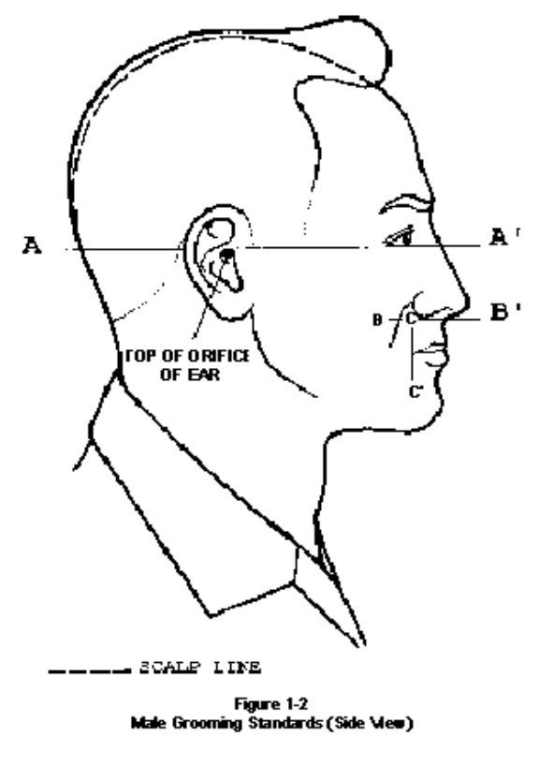

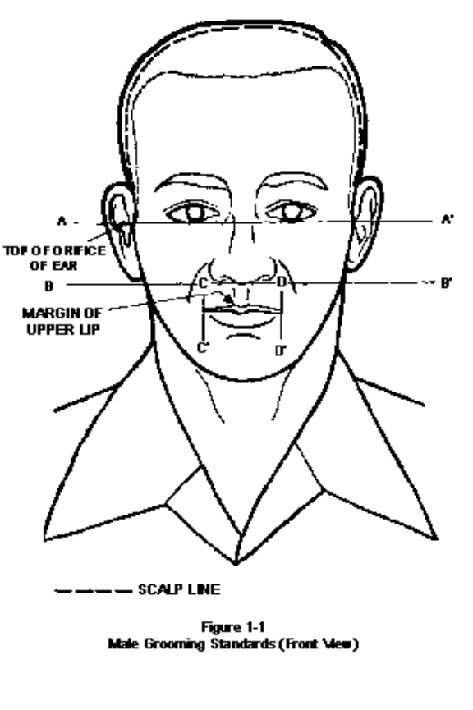

Female Hair Grooming Standards. Minimum length is one inch unless approved by the commander upon recommendation from a military treatment facility for medical reasons, to a maximum bulk of three inches from scalp. Hair may begin to gradually taper from one inch in length to ¼ inch in length approximately three inches from the hairline (no shaved heads, flat tops, etc.). Hair will end above the bottom edge of collar and any side of an invisible line drawn parallel to the ground. When in doubt, assess correct length of hair with Airman standing in the position of attention. Except in the physical training uniform (PTU), hair lengths that would be below the bottom edge of the collar will be pinned-up with no loose ends. Hair will not touch either eyebrow, to include an invisible line drawn across eyebrows and parallel to the ground. If worn, hairpins, combs, headbands, elastic bands and barrettes must match the hair color (i.e., blonde, brunette, natural red, black, grey), but hair must still comply with bulk and appearance standards. Ornaments are not authorized (i.e., ribbons, beads, jeweled pins).Scrunches are not authorized. Exception: While wearing the PTU, long hair will be secured but may have loose ends and may extend below the collar; i.e. ponytails.

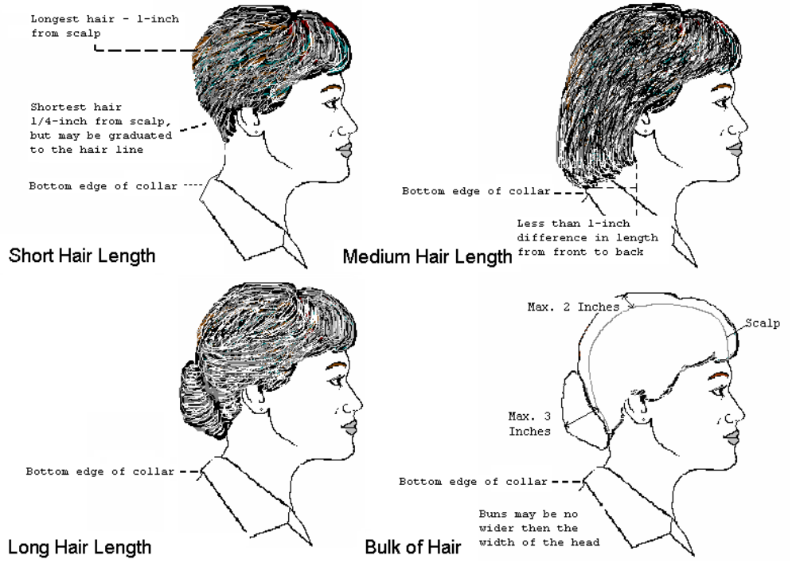

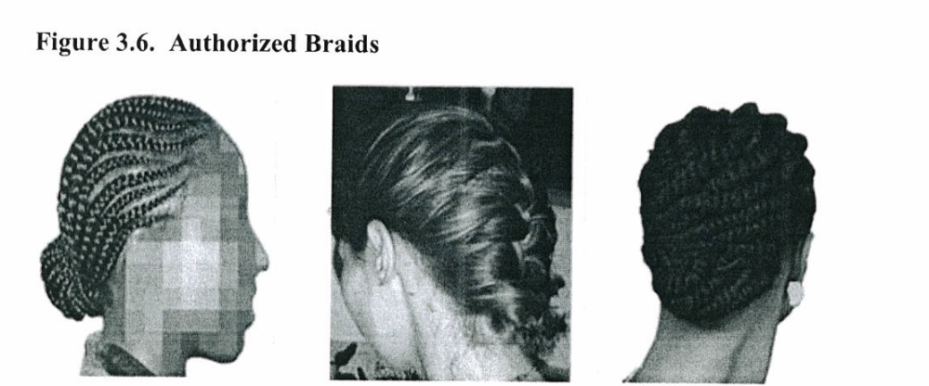

Braids, micro-braids and cornrows are authorized. However, they must be a natural looking color similar to the individual's hair color; conservative (moderate, being within reasonable limits; not excessive or extreme) and not present a faddish appearance. A braid is three or more portions/strands of interwoven hair. When worn, multiple braids shall be of uniform dimension, small in diameter (approx ¼ inches), show no more than ¼ inch of scalp between the braids and must be tightly interwoven to present a neat, professional and well-groomed appearance. Braids must continue to the end of the hair in one direction, in a straight line, and may be worn loose or a secured style within hair standards in the paragraph above for Female Hair Grooming Standards. Dreadlocks, (defined as portions of hair that have been intentionally or unintentionally fused together to form a loc or locs), shaved head, flat-tops and military high-and-tight cuts are not authorized hairstyles for female Airmen.

3-9. Enforcement

Cadet officers and NCOs have the authority and responsibility to enforce uniform standards. On the spot corrections are recommended. This authority must not be abused. Cadets correcting others are encouraged to do so privately and as discreetly as possible. Cadets receiving correction are encouraged to accept the action in the proper spirit. The best way to avoid conflict and embarrassment is to avoid violations. Any cadet who feels he/she has been treated unjustly should report the incident up the chain of command.

  - PT (Physical Training) Uniform Wear.

Students enrolled in Air Force JROTC at McNary High School will wear the approved PT uniform on specified PT days approved by the SASI. The approved PT uniform will be the standard AFJROTC charcoal gray issued T-shirt with the black issued shorts (personal black or dark blue PT shorts may be worn). The PT uniform must be worn properly and be neat and clean in appearance.
CHAPTER 4 - GRADING PROCEDURES

4-1. General

a. As in all formal education, a means of evaluating student progress is required. It is important that each cadet and their parents/guardians know how AFJROTC measures and reports progress in the program. AFJROTC follows the district-established grading standards that are shown below:

90%-100% is an "A"
80%-89% is a "B"
70%-79% is a "C"
60%-69% is a "D"
00%-59% is an "F"

b. The AFJROTC program consists of three separate but allied elements: Aerospace
Science, Leadership Education and Wellness Program. Each element is graded
separately; however, the three grades are combined to form a single grade for the
course. Aerospace Science (40%) and Leadership Education (40%) and
Wellness (20%) accounts for the total grade.

4-2. Aerospace Science (AS) Syllabus and Grading Procedures

a. DAILY REQUIREMENTS AND MATERIALS. Effective study skills, time management, and classroom responsibilities will be emphasized daily. Each cadet must be prepared for each class period by bringing to class:

(1) Completed assignments (2) Textbook
(3) Workbook (4) Pens and/or pencils
(5) Paper (loose leaf and a three-ring binder or notebook)
(6) Other materials as assigned

b. GRADING. The AS grade, which makes up forty percent of the TOTAL AFJROTC grade, will consist of a combination of workbook exercises, oral and written reports, in-class assignments, special projects, chapter tests, and a final examination.

c. TESTS. Chapter tests will be administered at regular intervals throughout the grading period. Tests, as well as other assignments are announced well in advance. An unexcused absence (DITCH) the day of a test earns a zero score for that test. If the absence is excused, the test may be taken after coordinating with the instructor.

d. OTHER WORK. Projects, workbook assignments, reports, and other homework assignments are due to the instructor at the beginning of the class period on the assigned date. There will be a 10 percent penalty deducted for each day the assignment is late. Late turn-ins will not be accepted after the test is administered for the corresponding homework assignment. There will be no penalty for work not turned in on time due to an excused absence. Late assignments after an excused absence are due the first day back at school. EXCEPTION: Extra days may be allowed with a request from a parent or guardian or at the discretion of the instructor.

e. Each cadet is personally responsible for assigned work. This information may also be obtained from the respective flight commanders and other cadets. Cadets are responsible for making arrangements with the instructor for making up missed tests.

f. Additional curriculum requirements for each course and instructions for each class are provided at the beginning of the school year.

g. AEROSPACE SCIENCE I (AS 100). JOURNEY INTO AVIATION HISTORY. This course is designed to acquaint the cadets with the history of aviation, and the impact that developments in aviation have had on technology, military aviation, transportation, national objectives, and policy-making both in peace and in war. The course surveys the early legends of flight, the first attempts to fly by the people in ancient civilizations, and the beginnings of scientific study into flight. It continues with the role of aviation during the early periods of American history, the contributions of the early pioneers in aviation, and the explosion in aviation technology and achievements during the period of the two World Wars from 1914 to 1945. The course then looks at military aviation and its roles during the post WW II years to include the Berlin Airlift, the Korean Conflict, the Cold War, the continuing research into faster and higher-flying aircraft, and the modern Air Force. TEXTBOOK: Aerospace Science: Journey into Aviation History.

h. AEROSPACE SCIENCE II (AS 200). THE SCIENCE OF FLIGHT. This course explores the science and laws of nature that govern and affect aviation. It provides an understanding of the atmosphere and elements of weather their effect on aviation, and the means and instruments used to measure atmospheric conditions. The course also surveys the basic principles of aerodynamics and how the principal laws of motion are applied to aircraft flight. The effect of flight on human physiology and how man has progressed in flight from the atmosphere to space by using specialized aerospace medicine, protective equipment, and training will also be discussed. Lastly, the course will introduce the basic principles of aerial navigation and chart interpretation. TEXTBOOK: Aerospace Science: The Science of Flight.

i. AEROSPACE SCIENCE III (AS 300). THE EXPLORATION OF SPACE. This yearlong course examines our Earth, the Moon and the planets in our solar system, the latest advances in space technology, and continuing challenges of space and manned space flight. The manned space flight section covers major milestones in the endeavor to land on the Moon, and to safely orbit humans and crafts in space for temporary and prolonged periods. It also covers the development of space stations, the Space Shuttle and its future, and international laws for the use and travel in space. This course also incorporates a block on model rocketry aerodynamics, construction, and performance. TEXTBOOK: Aerospace Science: The Exploration of Space.

j. AEROSPACE SCIENCE IV (AS 400). CADET CORPS MANAGEMENT. This yearlong course affords cadets the opportunity to put theories of previous leadership courses into practice. All the planning, organizing, coordinating, directing, controlling, and decision-making related to the leadership and management of the corps of cadets will be done by cadets. They will practice their communication, decision-making, personal interaction, managerial, and organizational skills as they lead in planning, coordinating, and prosecuting various projects, service opportunities, social events, etc.

4-3. Leadership Education (LE) Syllabus and Grading Procedures

a. The Leadership Education portion will be determined by the performance on workbook exercises, oral and written reports, chapter tests, final exam, drill and ceremony evaluations, and the wearing of the uniform. The LE portion will determine forty percent of the overall AFJROTC grade.

b. LEADERSHIP EDUCATION I (LE 100). This course will introduce cadets to the history, mission, purpose, goals, and objectives of Air Force JROTC. The course is designed to review and instill in new cadets the basics of citizenship that are important to be an effective member of the school and community. To that end the course will emphasize the importance of attitude, discipline, respect, and self-control. Additionally, it will also cover military traditions, flag etiquette and traditions, and living in a democratic society.

c. LEADERSHIP EDUCATION II (LE 200). This is a second year course emphasizing communications skills and the use of effective communications techniques. The course also covers working in teams, improving quality and productivity, and the complex art of leadership.

d. LEADERSHIP EDUCATION III (LE 300). The emphasis of the third year LE program is life skills and applied leadership principles. The cadets will be introduced to the basic phases in the job search, career opportunities, and the principles of sound financial planning and management. The cadets will be introduced to the basic phases in job search, financial planning, income taxes, financial planning and management.

- LEADERSHIP EDUCATION IV (LE 400). This is a fourth year course on principals of management. The course will cover introduction to management, planning, organizing and leading.

NOTE: All curriculum textbooks developed by Air Force Junior ROTC Curriculum
Section.

4-4. CADET LEADERSHIP COURSE (CLC) AS 41

The JROTC Cadet Leadership Course (CLC) is conducted every summer jointly with other area JROTC units. Slots for CLC are limited, therefore selection for CLC is generally restricted to the top 20% (leadership potential, academics, etc.) of the cadet corps. Selected cadets will normally stay at a camp in military-style dormitory rooms, and will live and work in a very controlled and supervised environment. Air Force instructors and adult supervisors will be present throughout the entire program. The program includes physical training, leadership laboratories, orienteering, drill and ceremony, and academic training on a variety of subjects. The program may be partially funded by the Air Force and cadet costs will be required. Full details and specific instructions will be made available during the Spring Semester.

4-5. JOINT SPRING LEADERSHIP CAMPS

Army JROTC leads an optional Spring Leadership Camp and invites the Air Force JROTC program to join. A few selected cadets can attend based on the same selection criteria as the Air Force CLC. Activities can include, obstacle courses, High ropes course, Leadership Reaction Courses, drill and ceremonies.

CHAPTER 5 - CADET BOARDS AND STAFF MEETINGS

5-1. Purpose

Cadet boards serve to select individuals for advancement, honors, to review and to make recommendations concerning alleged violations of established practices and procedures. Boards also allow cadets to gain experience in expression and self-confidence, and provide an excellent vehicle for leadership training by enabling senior cadets to serve in an evaluation and decision making capacity.

5-2. Responsibilities/Recommendations

a. Cadet boards will be appointed by the SAS/ASI.

b. Cadet boards are tasked to conduct inquiries and deliberations necessary for
ensuring the most equitable and recommendations. Board members must always
conduct themselves with the maximum degree of personal integrity and sincerity. After
due consideration of all the facts, specific recommendations must be submitted in
writing to the convening authority.

c. Members are required to keep the discussions and findings of the board strictly confidential or face possible punishment.

d. The board chairperson is responsible for ensuring that all board members, SASI/ASI, and other cadets required to be present are aware of the time and place for the proceedings. Additionally, he/she is responsible for the conduct of the board, minutes, recommendations, and final report.

5-3. Cadet Staff Meetings

a. The Cadet Group Commander (CC) or designated representative will chair a weekly staff meeting as deemed necessary. Any changes to this schedule must be approved by the SASI/ASI and published promptly. The CC, along with the Cadet Mission Support Squadron Commander, will prepare an agenda to ensure efficient use of time. Anyone wishing to present an item for discussion should notify the Cadet Mission Support Squadron Commander for inclusion in the agenda.

b. Staff meetings will be conducted in a military manner. All members will direct their attention to the business at hand. Meeting minutes will be taken by the Mission Support Squadron staff and published no later than two school days after the meeting.

c. For the purposes of the staff meeting, the term "staff" will be interpreted to include the Cadet Group Commander, Inspector General, Squadron Commanders, First Sergeant, Flight Commanders and Special Assistant to the SASI. The SASI and ASI will act as advisors.

CHAPTER 6 - SPECIAL ACTIVITIES

6-1. Purpose

Special activities are formed within the group promoting unity, while representing the unit and school, and performing formal functions.

6-2 Flag Detail

a. Each school day selected members of the corps have the responsibility of raising the United States and State of Oregon flags on the McNary High School campus. This is an honor and responsibility that cannot be taken lightly.

b. The Color Guard Commander and NCOIC will do the following:

(1) Designate a cadet to lead the flag details each morning before class.

(2) Designate a cadet to lead the flag detail at the end of the day.

(3) Ensure new cadets receive training and instruction on proper flag
etiquette and flag detail procedures.

(4) Observe/participate in flag raisings to promote understanding and respect.

(5) Develop a duty roster, (schedule), assigning cadets to raise and lower the flag each school day.

6-3. Color Guard

a. The Color Guard is composed of cadets who volunteer their time to the service of OR-20121. Members of the competitive Color Guard earn points towards the Drill Competition Ribbon and the Varsity school letter. The SASI/ASI will provide guidance on the award of a MHS Varsity Letter (Air Force Honor Guard Book). The Color Guard marches in parades and can compete in city, state, and national competitions.

b. Routine Color Guards are formed with any interested member of the unit. These Color Guards have the privilege of posting, presenting and carrying our National Colors at local community and school events. Participants earn points toward the award of the Color Guard Ribbon.

6-4. McNary Drill Team

The Drill Team offers the opportunity to polish the basic skills learned in drill and ceremony classes. Practice, extreme concentration, complete compliance with the drill team commander's commands, extra care of the uniform, the desire for public exhibition and recognition, and individual desire are all required to become an affective member of the team. The drill team performs precision drill maneuvers at school and unit activities, and marches behind the color guard in parades.

6-5. PT Team

The PT Team offers the opportunity for cadets looking for a physical challenge. Cadets participate in events including: push-ups, sit-ups, short and long distance running, and possibly obstacle courses, navigation, rappelling, low ropes courses, swimming and rowing.

6-6. Awareness Presentation Team (APT)

This team promotes the unit to gain more applicants into the AFJROTC program. Each presentation team is typically made up of three or four cadets presenting a skit/talk. Discussion or question/answer periods afterwards also often describe what AFJROTC is all about. In that respect, the APT can also be one of our most effective recruiting tools. APT members are selected on the basis of academics, appearance, and attitude. They serve as role models for the students of the schools they visit. APT members are awarded a distinctive APT badge and may earn the service ribbon after participating in two presentations.

6-7. Rocket/Model Club and Remote Controlled Aircraft

Members of this activity will learn basic model rocketry, building and launching of model rockets, building models and participation in rocket meets/competitions. During meet participation, prizes/trophies are normally offered for events such as altitude, duration, egg launch, spot landing, and appearance. Cadets who meet Air Force criteria are eligible for a rocketry badge to be worn with the uniform.

6-8. Group Newsletter

The Public Affairs Officer (PA) will publish a monthly OR-20121 newsletter for the purpose of publicizing unit events and corps activities. This newsletter will also serve as a vehicle to recognize individual and unit achievements and involvement in school and community affairs. The newsletter staff offers an opportunity for developing writing skills and basic publishing skills. The PA Officer is also responsible for filling out an announcement request (with SASI/ASI assistance), no later than the second day after an event has been completed to be included in daily announcements.

6-9. Flights in Air Force Aircraft

Typically seniors will have an opportunity to fly in Air Force aircraft when local flight scheduling allows. The flights are normally aboard local military flying squadrons. Flights usually last two to four hours and cadets may have an opportunity to ride in the cockpit! Normally, there is approximately one month notice and all required paperwork below must be completed and on file with the SASI/ASI.

a. CRITERIA FOR FLIGHTS. “A Strong Desire to Go!”

  - Complete and sign the Air Transport Agreement
  - Complete and sign Assumption of Risk and Liability Form
  - All required AFJROTC work completed
  - Good attendance in ROTC (this means nine or less absences) and no verified ditches for the semester.
  - A "C" or better in ROTC for the previous grading period.
  - No "Fs" in any class for the previous grading period.
  - No ear blocks, sinus blocks, severe head colds, etc.

b. Alternates. Normally three alternates will be designated for each flight. Alternates will be prioritized and will show up at the ROTC building, ready to fly, just like the primary cadets.

c. Instructions for specific flights will be made available as required.

6-10. Other Field Trips

Other field trips may include such destinations as Military Bases, air shows, aircraft museums, field day, adventure challenges, parades, rocket meets, and drill meets. They are fun, but "no pass--no play" is the rule. Participation in field trips requires that a cadet be passing all classes as of the last grading period. It also requires a properly filled out and signed parent/guardian permission slip. The paperwork must be turned in on time!

6-11. Military Ball

This annual, formal dinner-dance is the military equivalent of a prom. Non-cadets may be invited as dates, but cadets do not need to have a date to participate. The ball may be organized jointly with other units. Dress for male and female cadets is service dress uniform. Non-cadets are encouraged to dress in appropriate semi-formal civilian attire.

6-12. Dining-In

Unlike the military ball, the Dining-In is a formal dinner strictly for members of the unit. Dining-In will be led and directed by the Services Officer with the senior staff and guidance by the SASI/ASI. There will be one "guest of honor" as speaker and numerous special rules to follow. All cadets must be in full service dress or ABUs if it is a Combat Dining-In.

6-13. Kitty Hawk Air Society (KHAS)

The Chapter of the Kitty Hawk Air Society is the elite honor club for AFJROTC students promoting academic excellence, service, and citizenship. Once cadets pass an initiation, members are authorized to wear the KHAS pin and the blue rope. Eligibility criteria is as follows:

a. A minimum overall GPA of 3.00 and no failing grades in any class.

b. A grade of "B" or better in JROTC for the previous quarter report.

c. Demonstrated leadership qualities and high standards of morals and integrity.

d. Other requirements published by the KHAS Commander.

6-14. Community Service

Community service is one of the basic components of AFJROTC. Cadets are expected to give back to their school and community. Throughout the school year various community service projects will be conducted and cadets are expected to participate. They may be: stadium clean-up and parking for home football games, campus beautification, local community projects, visits to the VA or elderly communities and parades.

Cadets will be required to complete community service hours accordingly:
First Year Cadets- 15 service hours
Second Year Cadets- 20 service hours
Third Year Cadets- 25 service hours
Fourth Year Cadets- 30 service hours

6-15. Other Activities

Throughout the year cadets participate in other activities as determined and planned by the cadet staff. These activities include, but are not limited to, Basic Cadet Induction, BBQs, field days, community service projects, etc. Fundraisers are a vital part of our self-efficiency. It is imperative that every cadet participate in the majority of these fund raisers. It benefits all cadets, not just a few.

6-16. Participation by Non-Cadets

McNary High School students not enrolled in AFJROTC must have cadet staff, SASI/ASI, and parent/guardian approval to participate in cadet activities. Additionally they must also agree to comply with all cadet and event guidelines.

6-17. Basic Cadet Training

First year cadets will participate in a training event on a date to be determined. This fun event covers the basic cadet knowledge and team building that they will use throughout the year. Upon completion of BCT, cadets will earn the rank of Cadet Airman 1st Class (A1C).

6-19. Activity Fees

Throughout the school year there may be several activities that require a nominal fee to participate. i.e., (Military Ball, Cadet Leadership Course, Adventure Challenges, Drill Meets. Fund-raisers, Donations, etc.) Parents and cadets will be notified well in advance and funds will be collected and given a receipt for payment. To help off-set these costs, fundraisers will be coordinated and cadets who participate will be given monetary credit for their participation.

CHAPTER 7 - AWARDS AND DECORATIONS

7-1. Concept

Uniform and Awards, Operations Supplement 1 August 2018
Foreword
Unless otherwise noted in this publication, all uniform waivers to include drill team and color guard uniform waivers are hereby RESCINDED. ALL approved unit patch waivers are still valid.

Chapter 7 of this Operations Supplement describes how AFJROTC cadets will wear the uniform and maintain Air Force grooming standards while in uniform. AFI 36-2903, 13 July 2018, describes how to properly wear the Air Force uniform and this Operations Supplement describes how AFJROTC will wear rank, ribbons, medals, and other accouterments. Cadets are wearing the same basic uniform as the active duty Air Force, and they will be expected to honor and wear the uniform properly and with pride. This chapter provides the latest guidance and clarification on AFJROTC uniform wear for instructors and cadets. It also provides guidelines for cadet appearance and grooming.
The AFJROTC Awards and Decorations Program recognizes the achievements of AFJROTC cadets and fosters increased morale and esprit-de-corps. This chapter outlines the proper execution of a successful unit Awards and Decorations Program.

ACCOUTREMENTS (GENERAL)

7.2. Insignia Placement. Insignia on the AFJROTC uniform will be worn according to the figures contained in this guide.

7.3. Badges.

7.3.1. Ground School Badge. Awarded for successful completion of the AFJROTC aviation honors ground school curriculum or successful completion of another aviation ground school program prescribed by the FAA. Flight Suits are authorized for those cadets currently enrolled in or that have successfully completed aviation honors ground school, been awarded a flight solo badge, flight certificate badge or have successfully completed the AFJROTC Flight Academy program (see Attachment 7-12).

7.3.2. Flight Solo Badge. Awarded to any cadet possessing a solo flight certificate signed by a FAA certified flight instructor for either powered or non-powered aircraft. Flight suits are authorized for those cadets that have received their flight solo badge (see Attachment 7-12).

7.3.3. Flight Certificate Badge. Awarded to any cadet who possesses a valid FAA pilot’s certificate for either powered or non-powered aircraft. Flight suits are authorized for those cadets that have received their flight certificate badge (see Attachment 7-12).

7.3.4. Awareness Presentation Team Badge. Awarded for participation on an Awareness
Presentation Team. Criteria for becoming a member of the team will be published in the Cadet Guide or the Unit Operating Instructions.

7.3.5. Kitty Hawk Air Society Badge. Awarded to cadets who are members of the Kitty Hawk Air Society. The unit’s Kitty Hawk charter will spell out the requirements for entry into the society.

7.3.6. Academy of Model Aeronautics (AMA) wings. Awarded to cadets who are members of a local AMA chartered model airplane club.

7.3.7. Distinguished AFJROTC Cadet Badge. This annual award consists of a certificate and the Distinguished AFJROTC Cadet badge. The award recognizes one outstanding second- year cadet (third-year cadet in a 4-year program) selected at the end of each school year. This allows the recipient to wear the award their final year in the AFJROTC program. The recipient must be of high moral character, demonstrate positive personal attributes, display outstanding military potential, and maintain consistent academic and military excellence. The SASI, in coordination with the ASI and with the concurrence of the principal, selects the recipient of this award.

7.3.8. Aerospace Education Foundation (AEF) Academic Cadet Badge. Awarded to rising
Junior and Senior cadets for academic excellence as signified by attaining a minimum 3.3 grade point average (GPA) with no grade below a 2.0 GPA on their transcript. The individuals must be recommended by the SASI.

7.3.9. Model Rocketry Badge. Awarded to cadets who have fulfilled model rocketry program requirements. Program requirements are listed in the Model Rocketry Handbook available in WINGS.

7.3.10. Other Badges or Pins.

CyberPatriot and Stellar Explorer pins are issued to participating cadets by the host organization. Pins are not available for commercial purchase. Any badge or pin not specifically authorized by HQ AFJROTC will not be worn on any AFJROTC uniform combination.

7.3.11. Marksmanship Awards. Marksmanship competition awards/badges may be worn on the AFJROTC uniform. Males wear the badges under the ribbons on the left pocket flap of the light blue shirt or below the ribbons on the service dress uniform. Females wear the badges above the ribbons on both uniforms. Marksmanship badges will not be worn with medals.

7.4. Shoulder Patches.

7.4.1. AFJROTC Patch. Wear of the AFJROTC official shoulder patch is mandatory on the left sleeve of all uniforms except the raincoat, overcoat, all-weather coat, ABU (front left pocket only) and flight suit (above front right pocket area) . Cadets enrolled in Civil Air Patrol (CAP) and AFJROTC who use the same uniform for both activities may wear the CAP wing patch on the right shoulder sleeve.”

7.4.2. Unit Patch. Optional. If worn, must be on the right shoulder only (ABU on front right pocket only). Unit patches are paid for by non-Air Force Funds and must be approved by HQ AFJROTC via the waivers module in WINGS prior to purchase or use.

7.5. Shoulder Cords. Cadets are authorized to wear one shoulder cord (double knot, single cord – no aiguillettes or citation cords) on the left shoulder. This will be a single “infantry” style cord, without metal tips, no more than 1-inch wide. Wear the shoulder cord only on the light blue shirt and the service dress coat. The SASI will designate criteria on who may wear shoulder cords. Colors to denote different honors or leadership positions may be used.

7.5.1. Criteria for wear and shoulder cord colors will be described in the Cadet Guide or Unit Operating Instructions. On the service dress coat, the cord will be grounded to the left shoulder seam and pinned to the shoulder with the pin hidden beneath the cord. On the blue shirt, the cord will be under the epaulet, grounded to the left shoulder seam and pinned to the shoulder with the pin hidden beneath the cord.

7.6. Shoulder Tabs. Shoulder tabs are either cloth or metal arches denoting participation in an AFJROTC activity. Shoulder tabs are optional. If worn, cadets are authorized to wear one shoulder tab on the right shoulder of the service dress coat and the light blue shirt, centered between the unit patch and the shoulder seam. Tabs will have the name of the activity on them (e.g., drill team, saber team, honor guard, etc.). If no unit patch is worn, tab will be worn no lower than 1 inch below the shoulder seam. If a unit patch is worn, shoulder tab will be centered between the unit patch and the shoulder seam. The SASI will designate which activities will be denoted by shoulder tabs and set the criteria for each.

7.7. Awards and Decorations.

7.7.1. Awards and Decorations. The Cadet Awards and Decorations Program fosters morale, esprit-de-corps, and recognizes achievements of AFJROTC cadets. Awards sponsored by national organizations are funded by the sponsoring organization and donated through local chapters where available. Only Awards and Decorations approved by Holm Center/JR and listed in this guide may be worn. Units cannot purchase matching medals for HQ AFJROTC Approved Ribbons. (Example: Outstanding Cadet, Patriotic Flag,Bataan March, etc.). Only medals specifically designated within this Operational Supplement and depicted on the AFJROTC Ribbon Chart are approved.

7.7.1.1. Units may not create or purchase local awards (ribbon and/or medals) for wear on the uniform.

7.7.1.2. Ribbons will not be worn with medals. Medals may be worn with the service dress uniform for formal and semi-formal occasions of a limited nature (such as dining ins/outs, military ball, change of command ceremonies, awards ceremonies, picture days, or other formal events as specified by the SASI.) Medals may not be worn on regular uniform days. Place medals on the mounting rack in the proper order of precedence (see para 7.6.3.1).

7.7.1.3. Units are authorized to impose additional criteria (more stringent) to meet local standards and needs without diminishing minimum standards (example: limiting the number of cadets who may earn the award where no guidance is stated, or below stated limits). If such additional criteria are imposed, they must be specifically stated in the Cadet Guide or Unit Operating Instructions.

7.8. Order of Precedence of AFJROTC medals and ribbons.

7.8.1 AFJROTC Awards.
1. Gold Valor Award (Medal/Ribbon)
2. Silver Valor Award (Medal/Ribbon)
3. Cadet Humanitarian Award (Ribbon)
4. Silver Star Community Service with Excellence Ribbon
5. Community Service with Excellence Ribbon
6. Air Force Association Award (Medal/Ribbon)
7. Daedalian Award (Medal/Ribbon)
8. American Legion Scholastic Award (Medal/Ribbon)
9. American Legion General Military Excellence Award (Medal/Ribbon)
10. American Veterans Award (Medal/Ribbon)
11. Reserve Officers Association Award (Medal/Ribbon)
12. Military Order of World Wars Award (Medal/Ribbon)
13. Military Officers Association Award (Medal/Ribbon)
14. Veterans of Foreign Wars (VFW) Award (Medal/Ribbon)
15. Military Order of the Purple Heart Award (Medal/Ribbon)
16. Air Force Sergeants Association (AFSA) Award (Medal/Ribbon)
17. Tuskegee Airmen Incorporated AFJROTC Cadet Award (Ribbon)
18. The Retired Enlisted Association Award (Medal/Ribbon)
19. The Celebrate Freedom Foundation Award (Medal/Ribbon)
20. Air Commando Association Award (Medal/Ribbon)
21. Distinguished Unit Award with Merit (Ribbon)
22. Distinguished Unit Award (Ribbon)

23. Outstanding Organization Award (Ribbon)
24. Outstanding Flight Ribbon
25. Top Performer Ribbon
26. Outstanding Cadet Ribbon
27. Leadership Ribbon
28. Achievement Ribbon
29. Superior Performance Ribbon
30. Academic Ribbon
31. Cadet Leadership Course Ribbon
32. Special Teams Placement Ribbon
33. All Services National Competition (Medal/Ribbon)
34. Air Force Nationals Competition (Medal/Ribbon)
35. Orienteering Ribbon
36. Leadership Development Requirement (LDR) Leadership Ribbon
37. Drill Team Ribbon
38. Color Guard Ribbon
39. Saber Team Ribbon
40. Marksmanship Ribbon
41. Good Conduct Ribbon
42. Service Ribbon
43. Health and Wellness
44. Recruiting Ribbon
45. Activities Ribbon
46. Attendance Ribbon
47. Dress and Appearance Ribbon
48. Longevity Ribbon
49. Bataan Death March Memorial Hike Ribbon
50. Patriotic Flag Ribbon

7.8.2. AFJROTC cadets are not authorized to wear ribbons/medals earned/issued from Army, Navy, Marine Corps, or Coast Guard Junior ROTC programs. Cadets will be given equivalent AFJROTC ribbons to wear in lieu of Army, Navy, Marine Corps, or Coast Guard Junior ROTC ribbons/medals the cadet earned while serving in sister-service JROTC program. It is up to the SASI to make the best determination as to what equivalent AFJROTC ribbon to issue.

7.8.3. Badges or insignia from Active Duty, Guard, Reserve, or any other non-AFJROTC group are not authorized on the AFJROTC uniform. Badges, ribbons or insignia from middle school programs such as Youth Leadership Corps are not authorized on the AFJROTC uniform.

7.8.4 Descriptions and Criteria of AFJROTC Medals and Ribbons. Ribbons will not be worn with Medals (only the medals will be worn). NOTE: Medals will not be worn on regular uniform days or during any type of competition, i.e., drill, Cyber-Patriot, Academic Bowl, etc.

7.8.5. Gold Valor Award. Awards consist of a medal, ribbon, and certificate. The Gold Valor Award recognizes the most outstanding voluntary acts of self-sacrifice and personal bravery by a cadet involving conspicuous risk of life above and beyond the call of duty. Ribbon for this award may be worn on the cadet’s ribbon rack and worn on regular uniform days. Medals will not be worn on regular uniform days or during any type of competition.

7.8.6. Silver Valor Award. Awards consist of a medal, ribbon, and certificate. The Silver Valor Award is awarded to a cadet for a voluntary act of heroism which does not meet the risk-of-life requirements of the Gold Valor Award. Ribbon for this award may be worn on the cadet’s ribbon rack and worn on regular uniform days. Medals will not be worn on regular uniform days or during any type of competition.

7.8.7. Cadet Humanitarian Award. Award consists of a ribbon and certificate. It is intended to recognize cadets who provide aid in response to a singular extraordinary event such as a natural disaster or other catastrophe that has placed or has the potential to place a hardship on their fellow citizens. This award is not to be used to recognize day-to-day service in the community.

7.8.8. Silver Star Community Service with Excellence Award. Award consists of a ribbon with a Silver Star device and certificate. The Silver Star Community Service with Excellence Award will be an honor that emphasizes the value of community service, and establishes a greater sense of pride within the corps. The award will be given to cadets in the Top 5% of units (approximately 45 units) who have the highest "per cadet average" community service hours.

7.8.9. Community Service with Excellence Award. Award consists of a ribbon and certificate. It is intended to recognize those individual cadets who provide significant leadership in the planning, organizing, directing, and executing of a major unit community service project that greatly benefit the local community. This is not an award given to participants but to the key leader(s) of the project. Ribbon for this award may be worn on the cadet’s ribbon rack and worn on regular uniform days. Medals will not be worn on regular uniform days or during any type of competition, i.e., drill, Cyber-Patriot, Academic Bowl, etc. Cadets may only receive one National-level Award for each year they are in AFJROTC. Guidelines for National-level Awards will be followed to the fullest extent possible. Deviations from established award criteria will not be the norm, but based on a case, by case basis. Unit must uphold the “spirit of intent” of an award.

7.8.10. Air Force Association (AFA) Award. Cadets may only receive this award once. This AFA-sponsored award and is presented annually at each unit to the outstanding second-year (in a 3- year program) or third-year cadet (in a 4-year program). Ribbon for this award may be worn on the cadet’s ribbon rack and worn on regular uniform days. Medals will not be worn on regular uniform days or during any type of competition.

7.8.11. Daedalian Award. Cadets may only receive this award once. The Order of Daledalin’s is a fraternity of commissioned pilots from all military services. It is named after the legendary figure, Daedalus, and was organized by WWI military pilots who sought to perpetuate the spirit of patriotism, love of country, and the high ideals of self-sacrifice which place service to the nation above personal safety and position. This award is offered to encourage the development of these traits in cadets and to interest them in a military career. The medal is fashioned after an ancient Grecian plaque discovered by a Daedalian in the village of Lavadia, Greece and depicts Daedalus and his son Icarus fabricating their legendary wings of wax and feathers. Ribbon for this award may be worn on the cadet’s ribbon rack and worn on regular uniform days. Medals will not be worn on regular uniform days or during any type of competition.

7.8.11.1. This annual award recognizes one outstanding third-year cadet at each unit that meets the following criteria:
• Demonstrate an understanding and appreciation of patriotism, love of country, and service to the nation.
• Indicate the potential and desire to pursue a military career.
• Rank in the top 10% of their AFJROTC class.
• Rank in the top 20% of their school class.

7.8.12. American Legion Scholastic Award. Cadets may only receive this award once. Ribbon for this award may be worn on the cadet’s ribbon rack and worn on regular uniform days. Medals will not be worn on regular uniform days or during any type of competition.

7.8.12.1. This award is presented annually to one second- or third-year cadet (in a 3year program) or a third- or fourth-year cadet (in a 4-year program) based on the cadet’s overall scholastic achievements. Each cadet must:
• Rank in the top 10% of the high school class.
• Rank in the top 25% of their AFJROTC class.
• Demonstrate leadership qualities.
• Actively participate in student activities

7.8.13. American Legion General Military Excellence Award. Cadets may only receive this award once. Ribbon for this award may be worn on the cadet’s ribbon rack and worn on regular uniform days. Medals will not be worn on regular uniform days or during any type of competition.

7.8.13.1. This award is presented annually to one second- or third-year cadet (in a 3-year program) or a third- or fourth-year cadet (in a 4-year program) based on the cadet’s general military excellence. Each cadet must:
• Rank in the top 25% of their AFJROTC class.
• Demonstrate outstanding qualities in military leadership, discipline, character, and citizenship.
7.8.14. American Veterans (AMVETS) Award. Cadets may only receive this award once. Ribbon for this award may be worn on the cadet’s ribbon rack and worn on regular uniform days. Medals will not be worn on regular uniform days or during any type of competition.

7.8.14.1. This award is presented annually to one qualified cadet that possesses individual characteristics contributing to leadership such as:
• A positive attitude toward AFJROTC programs and service in the Air Force.
• Personal appearance (wearing of the uniform, posture, and grooming, but not physical characteristics per se).
• Personal attributes (initiative, dependability, judgment, and self-confidence).
• Officer potential (capacity for responsibility, adaptability, and maintenance of high personal standards).
• Obtained a grade of “A” (or the numerical equivalent) in their AS class.
• Be in good scholastic standing in all classes at the time of selection and at the time of presentation.

7.8.15. Reserve Officers Association (ROA) Award. Cadets may only receive this award once. Ribbon for this award may be worn on the cadet’s ribbon rack and worn on regular uniform days. Medals will not be worn on regular uniform days or during any type of competition.

7.8.15.1. This award is presented annually for military and academic achievement to an outstanding third-year cadet (fourth-year cadet in a 4-year program). The recipient must possess individual characteristics contributing to leadership such as:
• Be in the top 10% in the AFJROTC program.
• Be in the top 25% in academic grades.
• Be recognized for having contributed the most to advancing the objectives of the AFJROTC program, which include outstanding dedication to citizenship, knowledge of civic responsibility, military orientation, self-discipline and a sound work ethic.

7.8.16. Military Order of World Wars Award. Cadets may only receive this award once. Ribbon for this award may be worn on the cadet’s ribbon rack and worn on regular uniform days. Medals will not be worn on regular uniform days or during any type of competition.

7.8.16.1. This award is presented annually to an outstanding cadet who has committed to continue the aerospace science program the following school year. Selection is based on outstanding accomplishments or service to the AFJROTC unit.

7.8.17. Military Officers Association of America (MOAA) Award. Cadets may only receive this award once. This award, formerly known as The Retired Officers Association Award. Ribbon for this award may be worn on the cadet’s ribbon rack and worn on regular uniform days. Medals will not be worn on regular uniform days or during any type of competition.

7.8.17.1. This award is presented annually to an outstanding second-year cadet (third-year cadet in a 4-year program) who shows exceptional potential for military leadership. Each cadet must:
• Be a member of the junior class.
• Be in good academic standing.
• Be of high moral character.
• Show a high order of loyalty to the unit, school, and country.
• Show exceptional potential for military leadership.

7.8.18. Veterans of Foreign Wars (VFW) Award. Cadets may only receive this award once. Ribbon for this award may be worn on the cadet’s ribbon rack and worn on regular uniform days. Medals will not be worn on regular uniform days or during any type of competition.

7.8.18.1. This award presented annually to an outstanding second or third-year cadet in a 3-year program (third or fourth-year cadet in a 4-year program) who is actively engaged in
the AFJROTC program and who possesses individual characteristics contributing to leadership. Each cadet must:
• Positive attitude toward the AFJROTC program
• Must be enrolled as a 10th-12th grade AFJROTC student
• Must maintain a “B” average in AFJROTC curriculum and a “C” average in all remaining subjects with no failing grades in the previous semester
• Active in at least one other student extracurricular activity (music, athletics, government, etc.)
• Not a previous recipient of this award.

7.8.19. Military Order of the Purple Heart Award. Cadets may only receive this award once. Ribbon for this award may be worn on the cadet’s ribbon rack and worn on regular uniform days. Medals will not be worn on regular uniform days or during any type of competition.

7.8.19.1. This award annually recognizes an outstanding underclassman (first, second, or third-year cadet), who is enrolled in the AFJROTC program and demonstrates leadership ability. (Seniors are not eligible) Each cadet must:
• Have a positive attitude toward AFJROTC and country.
• Hold a leadership position in the cadet corps.
• Be active in school and community affairs.
• Attain a grade of “B” or better in all subjects for the previous semester.
• Not a previous recipient of this award.

7.8.20. Air Force Sergeants Association (AFSA) Award. Cadets may only receive this award once. Ribbon for this award may be worn on the cadet’s ribbon rack and worn on regular uniform days. Medals will not be worn on regular uniform days or during any type of competition.

7.8.20.1. This award recognizes an outstanding second- or third-year cadet in a three-year program (third- or fourth-year cadet in a 4-year program). The recipient must demonstrate outstanding qualities in military leadership, discipline, character, and citizenship. Each cadet must:

• Be in the top 10% of the AFJROTC class.
• Demonstrate outstanding qualities in military leadership, discipline, character, and citizenship.
• Not a previous recipient of this award.

7.8.21. Tuskegee Airmen Incorporated (TAI) AFJROTC Cadet Award. Ribbon for this award may be worn on the cadet’s ribbon rack and worn on regular uniform days.
7.8.21.1. This award is presented annually to two cadets. Cadets may be first-year, second year, or third-year cadets (in a 3- or 4-year program) and must meet the following criteria:
• Attain a grade of “B” or better in their AS class.
• Be in good academic standing.
• Actively participate in cadet corps activities.
• Participate in at least 50% of all unit service programs.

7.8.22. The Retired Enlisted Association (TREA) Award. Cadets may only receive this award once. Awarded annually, at the SASI’s discretion, for exceptional leadership to the most outstanding AFJROTC cadet while serving in an Enlisted Rank. The selected enlisted cadet must have shown outstanding leadership throughout the course of the school year. Ribbon for this award may be worn on the cadet’s ribbon rack and worn on regular uniform days. Medals will not be worn on regular uniform days or during any type of competition.

7.8.23. The Celebrate Freedom Foundation (CFF) Award for Excellence in Academic Programs. Cadets may only receive this award once. The awards program recognizes 9th, 10th, 11th and 12th grade students (including home-schooled students) enrolled in AFJROTC programs. Ribbon for this award may be worn on the cadet’s ribbon rack and worn on regular uniform days. Medals will not be worn on regular uniform days or during any type of competition.

7.8.23.1. Cadets must demonstrate the following personal characteristics to be eligible for nomination:
• Outstanding personal appearance (uniform and grooming)
• Display personal attributes such as initiative, judgment and self-confidence
• Courteous demeanor (promptness, obedience and respect for customs)
• Growth potential (capacity for responsibility, high productivity and adaptability to change)
• Possess the highest personal and ethical standards and strong positive convictions
• Shows the potential and desire to pursue a military career
• Rank in the top 5% in his/her AS class with a grade average of A or numerical equivalent
• Rank in the top 15 % of his/her academic class
• Demonstrates a positive attitude (toward AFJROTC and school)

7.8.24. Air Commando Association Award. Cadets may only receive this award once. Awarded annually at the SASI’s discretion for completing a one-page essay based on a historical AF Special Operations Mission possessing the 13 critical attributes of success: integrity, self-motivation, intelligence, self-discipline, perseverance, adaptability, maturity, judgment, selflessness, leadership, skilled, physical fitness and family strength. Ribbon for this award may be worn on the cadet’s ribbon rack and worn on regular uniform days. Medals will not be worn on regular uniform days or during any type of competition.

7.8.25. Distinguished Unit Award with Merit (DUAM). Award consists of a ribbon awarded to cadets enrolled during the same academic year in which 1) the unit receives a HQ AFJROTC evaluation with an overall rating of Exceeds Standards and 2) the unit is selected by HQ AFJROTC to receive the DUA. Both criteria must occur during the same academic year.
7.8.26. Distinguished Unit Award (DUA). Is a ribbon awarded to cadets enrolled during the academic year when a unit is selected by HQ AFJROTC to receive the DUA. The unit will receive a congratulatory letter and a certificate of recognition which will be posted in WINGS.

7.8.27. Outstanding Organization Award (OOA). Is a ribbon awarded to cadets enrolled during the academic year when a unit is selected by HQ AFJROTC to receive the OOA.

7.8.28. Outstanding Flight Ribbon. Is a ribbon awarded each academic term to members of the outstanding flight under criteria determined by the SASI. Criteria for this award will be published in the unit’s Cadet Guide.

7.8.29. Top Performer Award. The award consists of a ribbon and certificate presented/awarded only by Headquarters, AFJROTC personnel. This award is only
presented during a visit by HQ AFJROTC personnel. The award is presented to a maximum of 2% of the current unit cadet corps population (unduplicated headcount). Once awarded, the ribbon may be worn for the duration of a cadet’s tenure in AFJROTC.

7.8.29.1. Consideration for the Top Performer Awards. All currently enrolled cadets may be considered, but specific consideration will be given to cadets not previously recognized for superior performance. The Regional Director may select (SASIs may nominate) a maximum of 2% of a units cadets based on a cadet’s performance in the following key areas: Leadership and job performance: in primary duty and specifically in preparation for the unit’s assessment. Leadership qualities: involvement and positions held in Leadership Development Requirement activities. Academic performance: nominee must be in good academic standing in all high school course work, significant self-improvement, community involvement and other accomplishments.

7.8.30. Outstanding Cadet Ribbon. Is a ribbon awarded annually to the outstanding first-year, second-year, third-year, and fourth-year cadets. The recipient from each class must be of high moral character, demonstrate positive personal attributes, display outstanding military potential, and attain academic and military excellence. Criteria for this award will be published in the unit’s Cadet Guide.

7.8.31. Leadership Ribbon. Is a ribbon awarded for outstanding performance in a position of leadership as an AFJROTC cadet. Ensure recognition of cadets who have consistently displayed outstanding leadership ability above and beyond expected performance. Criteria for this award will be published in the unit’s Cadet Guide.

7.8.32. Achievement Ribbon. Is a ribbon awarded for a significant achievement in AFJROTC or other school activities/events. Individuals may not receive more than one ribbon during a 1-year period. Criteria for this award will be published in the unit’s Cadet Guide.

7.8.33. Superior Performance Ribbon. Is a ribbon awarded to no more than the top 10% of the cadet corps annually for outstanding achievement or meritorious service rendered specifically on behalf of AFJROTC. Present the ribbon for a single or sustained performance of a superior nature. Ensure award is presented in recognition of achievements and services which are clearly outstanding and exceptional when compared to achievements and accomplishments of other cadets. Criteria for this award will be published in the unit’s Cadet Guide.

7.8.34. Academic Ribbon. Is a ribbon awarded for academic excellence as signified by attaining an overall grade point average of at least “B” for one academic term, in addition to an “A” average in AFJROTC. Criteria for this award will be published in the unit’s Cadet Guide.

7.8.35. Cadet Leadership Course (CLC) Ribbon. Is a ribbon awarded for completion of an approved leadership school program of at least 5 days in duration. For each additional CLC completion an additional bronze star will be awarded. Silver Star will be awarded for outstanding performance or leadership ability at a CLC instead of the Bronze Star. Limit the Silver Star to 10% of the class. Criteria for this award will be published in the unit’s Cadet Guide.

7.8.36. Special Teams Competition Ribbon. Is a ribbon awarded to team members for placing 1st, 2nd or 3rd in an Air Force or Joint Service Competition to include Drill Teams, Color Guard Teams, Marksmanship Rifle Teams, Saber Teams, Academic Bowl Teams, CyberPatriot, StellarXplorers etc. For each additional ribbon earned an additional bronze oak leaf cluster will be awarded. A single silver oak leaf cluster will be used for the award of the fifth bronze oak leaf cluster.

7.8.37. Joint/All-Service National Competition Award. Is a medal/ribbon awarded to team members who competed at a Joint/All Service national-level competition to include Drill Teams, Color Guard Teams, Marksmanship Rifle Teams, Saber Teams, Academic Bowl Teams, CyberPatriot, StellarXplorers etc. For each additional ribbon earned an additional bronze oak leaf cluster will be awarded. A single silver oak leaf cluster will be used for the award of the fifth bronze oak leaf cluster. Medal may not (ribbon may) be worn during competitions and regular uniform wear days.

7.8.38. Air Force Nationals Competition Award. Is a medal/ribbon awarded to team members who competed at an Air Force only national-level competition to include Drill Teams, Color Guard Teams, Marksmanship Rifle Teams, Saber Teams, Academic Bowl Teams, CyberPatriot, StellarXplorers etc. For each additional ribbon earned an additional bronze oak leaf cluster will be awarded. A single silver oak leaf cluster will be used for the award of the fifth bronze oak leaf cluster. Medal may not (ribbon may) be worn during competitions and regular uniform wear days.

7.8.39. Orienteering Ribbon. Is a ribbon awarded to team members for completing a unit-specific Orienteering program as part of unit curriculum. Criteria for this award will be published in the unit’s Cadet Guide.

7.8.40. Leadership Development Requirement (LDR) Leadership Ribbon. Is a ribbon awarded at the SASI’s discretion for leadership in AFJROTC Leadership Development Requirement activities (such as but not limited to PT team commander, orienteering team commander, drill team commander, color guard team commander, dining-in chairperson, military ball chairperson, etc.). Criteria for this award will be published in the unit’s Cadet Guide.

7.8.41. Drill Team Ribbon. Cadets must be on the drill team for an entire year/drill season to be eligible to qualify and must have competed in at least 3 drill competitions. An oak leaf cluster will be added to this ribbon for each year of qualifying membership beginning with the second year. Criteria for this award will be published in the unit’s Cadet Guide.

7.8.42. Color Guard Ribbon. Cadets must perform at least 5 color guards to receive this ribbon. An oak leaf cluster will be added to this ribbon for each year of qualifying membership beginning with the second year. Criteria for this award will be published in the unit’s Cadet Guide.

7.8.43. Saber Team Ribbon. Cadets must perform at least 3 saber team events to receive this ribbon. An oak leaf cluster will be added to this ribbon for each year of qualifying membership beginning with the second year. Criteria for this award will be published in the unit’s Cadet Guide.

7.8.44. Marksmanship Team Ribbon. Cadets must be on the marksmanship team for an entire year season to be eligible to qualify and must have competed in at least 1 marksmanship postal competition. An oak leaf cluster will be added to this ribbon for each year of qualifying membership beginning with the second year. Criteria for this award will be published in the unit’s Cadet Guide.

7.8.45. Good Conduct Ribbon. Cadets must not have received a referral (this includes no ISS/OSS) and not missed more than 5 days of school (unexcused absences) for an entire school year to be eligible to qualify for this award. An oak leaf cluster will be added to this ribbon for each year of qualifying membership beginning with the second year. Criteria for this award will be published in the unit’s Cadet Guide.

7.8.46. Service Ribbon. Is a ribbon awarded for distinctive performance in school, community, or AFJROTC service projects. Limit to members whose active participation in a service project contributed significantly to the goals of the organization. (NOTE: Participation in Drill Teams, Saber Teams or Color Guard Teams alone does not qualify for the Service Ribbon (see above criteria for these other ribbons) unless community service hours are also awarded. Criteria for this award will be published in the unit’s Cadet Guide.
7.8.46.1 Cadets may earn service points through service activities that benefit of the community, school, or AFJROTC. Service activities may include fund-raisers, working at selected activities, some school projects, and community service. Service opportunities will be advertised through the staff meetings and Flight Commanders. Cadets should take note of the time, place, and specific requirements for participation in the event or activity and follow the instructions for signing up. Cadets must accrue 25 hours to earn the initial award. Additional entitlement may be earned for every 15 hour accrued after the initial 25 hours. All hours begin at the beginning of the school year and end at the conclusion of the same school year. There is no limit to the number of service ribbons that can be earned by a cadet.

NOTE: On a case-by-case basis, the SASI/ASI may designate a single event or project as being sufficient for earning a service ribbon regardless of the number of hours worked. These events will be clearly advertised and communicated to the cadet corps.

7.8.47. Health and Wellness Ribbon. Is a ribbon awarded for participation in the unit health and wellness physical fitness program. All cadets who participate in the unit’s wellness program may receive the Health and Wellness Ribbon. Subsequent yearly award of the Health and Wellness Ribbon will be denoted by the addition of a Bronze Oak Leaf cluster to the ribbon for each additional year of award. Cadets who score in the Physical Fitness Test’s 75-84% will receive a Bronze Star device; 85-95% will receive a Silver Star device; and 96-100% will receive a Gold Star device. These cadets, if already wearing the ribbon with oak leaf cluster(s), will receive and wear an additional Health and Wellness Ribbon with the highest-level Star Device(s) affixed. Duplicate awards of the Bronze, Silver or Gold percentile will be denoted by the addition of another star on this ribbon. Should a cadet subsequently score in a higher percentile, only the star representing the higher percentile will be worn. In no case will a cadet mix different color stars, or star(s) and oak leaf cluster(s) on the same ribbon. Criteria for this award will be published in the unit’s Cadet Guide.

7.8.48. Recruiting Ribbon. Is a ribbon awarded for outstanding effort in support of unit recruiting activities. Cadets must have directly contributed to the recruitment of two new members to AFJROTC. Criteria for this award will be published in the unit’s Cadet Guide.

7.8.49. Activities Ribbon. Is a ribbon awarded for participation in Leadership Development Requirement (LDR) activities other than those that qualify for the Color Guard, Drill Team, and Special Teams Competition ribbons. These include, but are not limited to orienteering teams, model rocketry clubs, academic bowl teams, and raider/sports teams. An oak leaf cluster will be added to this ribbon for each year of membership beginning with the second year. Criteria for this award will be published in the unit’s Cadet Guide.

7.8.50. Attendance Ribbon. Is awarded to cadets who have no more than three excused absences (no unexcused) from AFJROTC classes during an entire school year. Criteria for this award will be published in the unit’s Cadet Guide.

7.8.51. Dress and Appearance Ribbon. Is awarded to cadets who maintain a 90% or higher average on weekly uniform grades. Cadets receiving this award will maintain the highest grooming and dress standards possible. Criteria for this award will be published in the unit’s Cadet Guide.

7.8.52. Longevity Ribbon. Is a ribbon awarded for successful completion of each AFJROTC school year (semester with a 4X4 block schedule). Criteria for this award will be published in the unit’s Cadet Guide.

7.8.53. Bataan Death March Memorial Hike Ribbon. Is a ribbon awarded to honor and remember the sacrifices of the victims and survivors of World War II’s Bataan Death March, AFJROTC units may conduct an optional 14-mile Bataan Death March Memorial Hike. This event must be accomplished on a locally determined 14-mile course (trails, road courses, tracks, etc.,). Units may complete the full hike in a span of one to no more than 3- days. Cadet safety must be monitored at all times and advanced planning for any first aid/medical attention is paramount. Cadets who fully complete the 14-mile hike are authorized to wear the ribbon. Additionally, no fees can be charged to participate in the Memorial March. However, units are encouraged to collect donations which will be given to reputable organizations that benefit disabled veterans such as The Air Force Association’s Wounded Airman Program, the Wounded Warrior Project, Special Operations Warrior Foundation, etc. Criteria for this award will be published in the unit’s Cadet Guide.

7.8.54. Patriotic Flag Ribbon. Is a ribbon awarded for participation in non-color guard events specifically designed to honor our nation’s flag. Such events include flag raising ceremonies, flag retirement ceremonies, flag folding ceremonies, and historical flag demonstrations. In order to receive this award, cadets must have participated in a minimum of 5 flag events. Criteria for this award will be published in the unit’s Cadet Guide.

7-9. Cadet of the Month/Cadet of the Semester

a. Cadets, regardless of rank, can be nominated for Cadet of the Month by the SASI/ASI.

b. Cadet of the Month: Cadets nominated for this award will be interviewed in uniform to help the selection board arrive at a final decision. The board will consist of members of the Kitty Hawk Air Society. You will be asked a series of questions ranging from handbook knowledge, classroom discussion, or Chain of command, and uniform wear.

c. Cadet of the Semester: Cadets who were selected as a Cadet of the Month during the semester will be in competition for Cadet of the Semester. The recipient will be selected by the AFJROTC instructors.

CHAPTER 8 - CAREER PLANNING AND PREPARATION

8-1. Concept

During high school, students should insure that planning and preparations for lifetime vocations are well under way. Your individual counselor and “The Source” are always a valuable source of information and guidance in helping with your career decisions. Additionally, the SASI and ASI have many years of military experience on which to draw on to help you.

Service Academy Appointments
Cadets should consider applying for competitive service academy appointment during their high school junior year. A suggested "timeline" for completing the application packages will be made available through the SASI at the beginning of the school year.

College ROTC Scholarships

Information is available in the AFJROTC office. Normally, applications must be received by the respective services by December 1st of the cadet’s senior year. Cadets are urged to visit the local university ROTC programs. Cadets applying for an Air Force ROTC scholarship should see the SASI. Cadets applying for other services’ ROTC scholarship should contact the respective recruiters or the nearest university ROTC detachment.

8-4. AFROTC Scholarships
These are college scholarships available to AFJROTC cadets who will have completed at least two years in the program prior to graduating in their senior year. The scholarship may pay up to 100% of college tuition for four years, lab fees, books, and up to $500 per month stipend. Procedures and benefits may vary yearly based on HQ ROTC guidance and the needs of the Air Force; cadets should see the SASI for specific details of these scholarships early in their junior year.

8-5. Service Enlistment

Cadets considering entering the military service have many qualifications as a result of their JROTC experience; an additional benefit gained from JROTC includes enlistment at a higher pay grade. Service recruiters are available to answer your questions.

8-6. Armed Services Vocational Aptitude Battery (ASVAB) Test
The ASVAB predicts basic aptitudes, skills, abilities, and probable success in mechanical, electrical, administrative and general specialty areas. This service-administered test is absolutely free and has no obligation of any sort. The test is used for career field placement if an individual decides to enter military service.

ATTACHMENTS

Attachment 1

UNIT MANNING DOCUMENT

Air Force Junior ROTC Cadet Group
OR-20121

Supervisor Position Title Maximum Grade Authorized

Group CC - Group Commander C/Lt Col 1
- Inspector General C/Capt 1
- Inspector C/1st Lt 1
- Operations Squadron Commander C/Maj 1
- Mission Support Squadron Commander C/Capt 1
- Services Squadron Commander C/Capt 1
- Recruiting Squadron Commander C/Capt 1
- Logistics Squadron Commander C/Capt 1
- Cadet Group First Sergeant C/CMSgt 1

Operations - Operations Superintendent C/SMSgt 1
Squadron
- Armed Team Commander 1
- Unarmed Team Commander 1
- Color Guard Commander 1
- PT Team Commander 1
- Saber Team Commander 1

Mission - Mission Support Superintendent C/SMSgt 1
Support - Public Affairs Officer/NCO 1
Squadron - Website/Social Media Officer/NCO 1
- Group Historian Officer/NCO 1

Services - Services Superintendent C/SMSgt 1
Squadron - Kitty Hawk Air Society Commander 1
- Athletics Officer 1
- Rocket Club Commander 1

Recruiting - Recruiting Superintendent C/SMSgt 1
Squadron - Retention Officer/NCO 1
-APT Commander 1

Logistics - Logistics Superintendent C/SMSgt 1
Squadron - Armory NCOIC 1
-Armory NCO 1
- Flight Commanders 6

Attachment 2

JOB DISCRIPTIONS

GROUP COMMANDER IS RESPONSIBLE FOR: (CGp/CC)

- Reports directly to the SASI/ASI
- The appearance, discipline, effectiveness, training and conduct of the cadet operations group.
- Oversee and supervise the activities of subordinates under their control.
- Coordinate, chair and attend command staff meetings
- Brief SASI/ASI on the condition, morale and welfare of group.
- Other duties as assigned by the SASI/ASI.

GROUP FIRST SERGEANT IS RESPONSIBLE FOR: (CGp/CCF)

- Reports directly to the CGP/CC
- Maintain appearance, discipline, and motivation of the enlisted corps.
- Enforces all standards established by the CC
- Counsels enlisted members on disciplinary matters as
well as recommends cadets for boards and recognition.
- Provide recommendations to the CGP/CC based on inputs from lower ranking enlisted cadets and acts as a liaison between the corps and group staff.
- Advises the CGP/CC on problems with the corps and suggest possible solutions.
- Oversees the activities of the NCO corps
- Conducts NCO meeting twice monthly
- Conducts weekly safety inspections of all cadet
facilities.
- Reports all safety violations or findings to the CGP/CC
SASI/ASI and provide recommendations for correcting
safety related issues.
- Complete school/district work-orders when necessary
- Conduct a safety briefing with all cadets prior to any activity, function,
drill meet or field trip.
- Annotate and print safety briefings on computer and obtain signatures from all attending cadets.
- Maintain safety log with all briefings and write ups
- Ensures all safety equipment is staged and ready to support activities and events
- Any additional duties assigned by the CGP/CC

INSPECTOR GENERAL IS RESPONSIBLE FOR: (CGp/IG)

- Reports directly to the SASI
- During HQAFJROTC inspections, assist cadre with Inspection checklist
-- Keep HQ Inspection booklet up-to-date
- Direct reporting office for any concerns of the Group
- Oversee and provide accountability and reports on weekly uniform/PT inspections
- Conduct weekly inspections on each Squadron
--Weekly inspections will consist of suspense updates and program status
- Provide CGP/CC weekly updates on status of inspections
- Provide SASI/ASI daily/weekly status of Group day-to-day operations
- Other duties assigned by the SASI/ASI

OPERATIONS SQUADRON COMMANDER IS RESPONSIBLE FOR: (COS/CC)

- Reports directly to the CGP/CC
- Oversee cadet drill training by heading after school Drill class
- Oversee cadet Special Forces team by keeping abreast of their activities and training
- Overseeing the Flight Commanders
- Relay information from senior staff to Flight CCs
- Acts as liaison between flights and CGP/CC
- Oversees the activities of subordinates under their control
- Creating and conducting standard evaluations (Stan/Evals) for the cadet operations group.
- Ensure all cadet operations group activities are conducted in accordance with current air force, Holm Center, AFJROTC and locally developed directives, policies and procedures.
- Perform other duties as assigned by the CGp/CC.

FLIGHT COMMANDERS ARE RESPONSIBLE FOR (COS/FltCC)

- Reports directly to the COS/CC
- Maintain the appearance, discipline, efficiency, training
and conduct of the flight
- Plan and coordinate all activities within the flight
- Ensure all Flight Documentation is accurately annotated
- Any additional duties assigned by the COS/CC

McNARY’S ARMED DRILL TEAM COMMANDER IS RESPONSIBLE FOR (COS/ATCC)

- Reports directly to the COS/CC
- Ensures training schedule is followed by each team member
- Establishes a daily training schedule outlining specific training requirements
- Ensures all team members are trained and certified, maintains training record for
each team member.
- Monitors and supervises all armed teams, ensures appointed commander complies with all directives and training requirements
- Ensures all required equipment is prepared and staged prior to each activity/event
- Devise, create and supervise new routines for drill competitions
- Maintains serviceability of all assigned equipment
- Any additional duties assigned by the COS/CC

McNARY’S UNARMED DRILL TEAM COMMANDER IS RESPONSIBLE FOR (COS/UACC)

- Reports directly to the COS/CC
- Ensures training schedule is followed by each team member
- Establishes a daily training schedule outlining specific training requirements
- Ensures all team members are trained and certified, maintains training record for
each team member.
- Monitors and supervises all unarmed four person teams, ensures four person commander complies with all directives and training requirements
- Ensures all required equipment is prepared and staged prior to each activity/event
- Devise, create and supervise new routines for drill competitions
- Maintains serviceability of all assigned equipment
- Any additional duties assigned by the COS/CC

McNARY’S COLOR GUARD COMMANDER IS RESPONSIBLE FOR (COS/CGCC)

- Reports directly to the COS/CC
- Ensures training schedule is followed by each team member
- Establishes a daily training schedule outlining specific training requirements
- Ensures all team members are trained and certified, maintains training record for
each team member.
- Monitors and supervises all teams, ensures appointed team commanders complies with all directives and training requirements
- Ensures all required equipment is prepared and staged prior to each activity/event
- Selects team members for all scheduled color guard request
- Maintains serviceability of all assigned equipment
- Any additional duties assigned by the COS/CC

PT TEAM COMMANDER IS RESPONSIBLE FOR (COS/SFCC)
- Reports directly to the COS/CC
- Establishes Chain of Command specific to PT Teams
- Ensures training schedule is followed by each team member
- Establishes a daily training schedule outlining specific training requirements
- Ensures all team members are trained and certified, maintains training record for
each team member.
- Monitors and supervises all teams, ensures team commanders complies with all directives and training requirements
- Ensures all required equipment is prepared and staged prior to each activity/event
- Maintains serviceability of all assigned equipment
- Briefs and debriefs every competition
- Attends any and all competition meetings

MISSION SUPPORT SQUADRON COMMANDER IS RESPONSIBLE FOR (CMSS/CC)

- Reports directly to the CGP/CC
- Ensure proper maintenance of administrative and personnel files
- Oversees all activities of the Public Affairs
- Maintain the group’s organizational chart and unit manning document
- Publish a cadet directory
- Writing and posting weekly staff meeting minutes
- Maintain administrative files in accordance with
established policies and procedures
- Maintain bulletin boards
- Maintain group continuity files
- Maintain and update cadet forms and regulations
- Maintain cadet personnel records
- File all documentation in cadet records or other internal media
- Input Cadet data into the Cadet Inventory Management Program
- Prepares all request forms for events and activities
- Assist CSV/CGCC with administrative functions of Drill competitions
- Assist CSV/RMCC with administrative functions of club competitions
- Responsible for tracking cadet rank through promotion system
- Any additional duties assigned by the CGP/CC

PUBLIC AFFAIRS OFFICER IS RESPONSIBLE FOR: (CMSS/DPA)

- Reports directly to the CMSS/CC
- Maintain all Unit display boards
- Maintain and update Cadet of the Month/Semester Boards
- Establish an active public affairs program
- Submit news articles to school and local newspapers
concerning cadet activities
- Update Unit informational slideshow on TV screen daily
- Provides all unit photographic services
- Assist briefers with graphic support
- Establish and maintain Historical Logs and Booklets
- Construct and maintain hard copies and CDs of all unit pictures
- All other duties assigned by the CMSS/CC

WEBSITE/SOCIAL MEDIA OFFICER/NCOIC IS RESPONSIBLE FOR: (CMSS/DPAW)

- Reports directly to CMSS/DPA
- Maintains Unit Website
- Updates all Website Information
- Updates Website Videos
- Updates Website AFJROTC and Unit Chain of Command Information
- Coordinates with DPA for Photos/Graphics for the Website
- Ensures collection and accountability of Student Publication/Audio Release Forms
- Establishes and Maintains all Unit Social Media Sites to include but not limited to;
Facebook, Instagram, Twitter and Kik
- Monitors and Updates all Social Media Information
- Report any Social Media unprofessional conduct, misbehavior and/or harassment
- Coordinates with DPA for Photos/Graphics for Social Media Outlets
- All other duties assigned by the CMSS/DPA

GROUP HISTORIAN IS RESPONSIBLE FOR
- Reports directly to the CMSS/CC
- Establishes and maintains a unit historical library
- Maintains all unit documentation and insures it is properly saved and archived
- Ensures local public articles on unit are saved and stored
- Saves and archives all unit photos and videos

SERVICES SQUADRON COMMANDER IS RESPONSIBLE FOR (CSV/CC)

- Reports directly to the CGP/CC
- Oversees activities of subordinates under their squadron
- Ensure a high level of morale and esprit de corps is maintained within the unit
- Promote high levels of physical fitness within the unit
- Any additional duties assigned by the CGp/CC
- Establish, maintain and execute programs to recruit potential cadets into the program
- Establish an APT team and select members from each flight to serve on team
- Establish and execute a retention program to encourage cadets to remain in the
program
- Submit After Action Reports to CGp/CC within fourteen days after event
- Plans, coordinates and executes all group special projects
i.e.: Military Ball, BBQs, Awards Night,
Base Trips, Change of Command Ceremonies,
- Construct and submit after actions reports to the CGP/CC within seven days after each project
- Establish, coordinate and execute programs to retain current cadets in program
- Plan and coordinate extracurricular and co-curricular
activities with other school organizations
- Assist the SASI/ASI in scheduling cadets for base visits
and similar activities
- Any additional duties assigned by the CGP/CC

COMBAT DINING-IN/BCI OFFICER IS RESPONSIBLE FOR: (CSV/BCI)

- Reports directly to the CSV/CC
- Lead, plan and develop the BCT training day for all first year cadets
- Provide events, challenges, activities and testing for all first year cadets
- Track cadets who miss BCT and provide make-up testing
- Provide certificates, ribbon and rank for all BCT graduates
- Lead, plan and develop a Combat Dining-In for all cadets
- Arrange a guest of honor as a guest speaker
- Secure a facility for the event
- Plan and provide a Grog Bowl for the event

KITTY HAWK AIR SOCIETY COMMANDER IS RESPONSIBLE FOR (CSV/KHAS)

- Reports directly to the CSV/CC
- Responsible for an initiation day to induct new members
- Creates a Chain of Command Specific to KHAS
- Controls all activities of the groups Kitty Hawk Air Society
- Selects KHAS members to serve as tutors for cadets
struggling academically
- Encourage and recruit corps members who meet the GPA
standards for membership
- Prepares, Plans and Chairs all Cadet of the Month/Semester Boards
- Creates a promotion test with instructors approval, per grade level, for promotion
- All other duties assigned by the CSV/CC

ATHLETICS OFFICER/NCO IS RESPONSIBLE FOR (CSV/PT)

- Reports directly to the CSV/CC
- Develop weekly schedule of physical training activities for PT days
- Operate a voluntary cadet physical fitness program
- Supervise formal exercise program established by SASI/ASI
- Post current health awareness information
- Manage, supervise and execute all field day activities
- Any additional duties assigned by the CSV/CC

ROCKET CLUB COMMANDER IS RESPONSIBLE FOR (CSV/RMCC)

- Reports directly to the CSV/CC
- Planning and executing all rocket/model meets
- Ensure team members are trained and informed on all rocket/model club requirements and information
- Ensures all equipment is serviceable and accountable
- Any additional duties assigned by the CSV/CC

RECRUITING SQUADRON COMMANDER IS RESPONSIBLE FOR (CREC/CC)

- Reports directly to the CGP/CC
- Oversees all recruiting and retention activities
- Coordinates, Plans and schedules Junior High Visits
- Plans, coordinate and schedules activities to recruit possible cadets from the school
campus
- Plans, coordinate and schedules activities to increase retention of current cadet roster
- Any additional duties assigned by the CGP/CC

RETENTION OFFICER IS RESPONSIBLE FOR (CREC/RET)

- Reports directly to the CREC/CC
- Creates and distributes quarterly unit climate surveys
- Facilitates quarterly feedback sessions
- Creates activities and competitions between flights (i.e., sports, shields, chants, etc)
- Works with local support organizations (ANG) to create fun days
- Any additional duties assigned by the CREC/CC

AWARENESS PRESENTATION TEAM COMMANDER IS RESPONSIBLE FOR (CREC/APT)

- Reports directly to the CREC/CC
- Plan, coordinate and execute presentations to local schools and community
organizations
- Develop slide presentations and skits to perform
-Train all APT members in their duties
- Maintain rosters of presentations performed and members in attendance
- Report to Corps after every presentation through members in each flight
- Any additional duties assigned by the CREC/CC

LOGISTICS SQUADRON COMMANDER IS RESPONSIBLE FOR (CLOG/CC)

- Reports directly to the CGP/CC
- Maintain an inventory of on-hand supplies/equipment, uniforms and textbooks
- Maintain inventory of all assigned weapons
- Maintain inventory in the cadet inventory management computer program
- Supervise all flight supply representatives
- Develop, in writing, procedures for uniform replacement items (works with ASI to accomplish task)
- Distribute supplies to all functional areas
- Select and supervise two armory personnel to manage unit armory
- Any additional duties assigned by the CGP/CC

AMORY NCOIC IS RESPONSIBLE FOR (CLOG/ARM)

- Reports directly to the CLOG/CC
- Insures all facsimile rifles and sabers are accountable after every use
- Conduct and inventory count on a weekly basis
- Insures all accountable items are signed out and in when being used
- Insures all items are clean and serviceable an ready for competition
- Insures all locks and lockers are serviceable and SF Form 102 used

* Note: All team and club commanders need to post the requirements for earning each of the following:

- Membership
- Cords
- Berets
- Badges/Emblems
- Competing (if applicable)

Attachment 3
COMPUTER PROCEDURES

1. The computers located in the staff area are for cadet use only. Non-cadets WILL NOT use these computers. The computers are available for JROTC business, academic assignments, and projects. These computers are not for personal use. Any violation of this rule will result in losing all computer privileges.

2. Computers may be used subject to the following procedures.

a. Do not save any school assignment or project on the hard drive. Hard drives may be defragged, wiped, reformatted, etc. without notice. The JROTC staff and instructors are not responsible for any school material saved on the hard drive.

b. Do not change any of the computer settings, screen savers, defaults, etc. This will result in disciplinary action and losing computer use privileges.

c. If a malfunction occurs when using the computer do not attempt to fix it yourself. Ask for assistance from the SASI/ASI.

- Access to the Internet. Any cadet access to the Internet will be in accordance with McNary Public Schools District codes, Air Force Instructions 36-112 and 36-119, and AFROTC Instruction 33-105. Cadets wishing to take advantage of Internet access for school research, projects, and JROTC will ask the SASI/ASI for this privilege.

  - Obtain permission from the SASI/ASI.

Attachment 4

CADET STAFF AREA and CLASSROOM

PROCEDURES

1. The cadet staff area and classroom are a privilege for cadets and their guests -- not a guaranteed right. This privilege may be revoked by the command staff and SASI/ASI at any time and for any length of time.

2. These rooms and its contents will remain clean and neat at all times. EVERY cadet is responsible for these rooms. All unwanted trash will be thrown away in the garbage can prior to departing these rooms.

3. Cadets are responsible for their actions. Guests WILL NOT BE ALLOWED in the JROTC classroom/area unless approved by the SASI/ASI.

4. The JROTC area WILL NOT be used for temporary storage of cadet belongings. All cadet property will be taken with the cadet when they leave the area. DO NOT leave personal items unattended (wallet, purse, radios, sunglasses, etc.)

5. The tables, chairs, bookshelves, cabinets, microwave, etc. WILL NOT be moved without prior permission from SASI/ASI. Once again, these items are not cadet property. All items are property of the Air Force, McNary High, the SASI, or ASI. When cadets leave, the rooms will be returned to their original condition (lights off, chairs grounded, cleaning items returned, etc.) All classroom guidelines regarding the use of furniture will be followed in the break room. Clothes bags, book bags, etc., WILL NOT be placed on tables.

6. Loud/excessive noise WILL NOT be tolerated (music, yelling, or screaming, etc.) Absolutely NO horseplay will be allowed.

7. There will be absolutely no PDA by cadets in the cadet area rooms or anywhere
else in/around or in view of the JROTC facility.

8. Computers (including laptops) must be used for educational purposes only...

Attachment 5

CADET OF THE MONTH / SEMESTER

1. CADET OF THE MONTH: Cadets will be nominated by the SASI/ASI no later than the 3rd school day after the beginning of each new month.

2. The nominee will meet a board constructed of Kitty Hawk Air Society members and key staff members. Nominees will answer questions relating to Air Force history, chain of command, organization and mission, uniform wear, etc…. Board results will be provided to the SASI by COB of the scheduled board day.

3. The Cadet of the Month program was established to recognize outstanding cadets in their dedication to the squadron, school, and community, as well as improve morale.

4. CADET OF THE SEMESTER: At the end of each semester, all cadets that were selected as cadet of the month for that semester will be in contention for Cadet of the Semester. Recipients will be recognized and awarded prizes for their accomplishment.

Attachment 6

BULLETIN BOARDS and TV DISPLAYS

1. BULLETIN BOARDS and TV DISPLAYS: These displays are to be used for official business / announcements such as, but not limited to:

a. Current events
b. General / School/AFJROTC announcements
c. Co-curricular meeting times and places
d. Temporary / permanent information posted by the SASI/ASI
e. Calendar of Upcoming Activities

2. Except for Command Staff members, all other cadets must have prior permission from the CMSSq/CC, CGP/CC, SASI, or ASI prior to posting anything on the bulletin boards or TV displays.

3. The Public Affairs Officer will check the bulletin boards and TV displays weekly for compliance. The individual who requested the material to be posted has the responsibility of removing it on the expiration date.

4. Information posted on the bulletin boards will normally be no smaller than 3 X 5 and no larger than 8 ½ X 11. (Exceptions may be approved by the SASI/ASI). All bulletin board material will be secured with a thumb tack or push pin in all four corners. Items placed on whiteboards will be secured by magnets (DO NOT use tape). The bulletin board will be kept neat and current at all times.

Attachment 7
AUTHORIZED AIR FORCE JROTC BADGES AND INSIGNIA


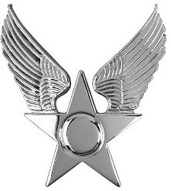

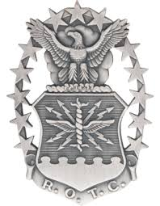

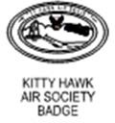
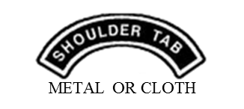

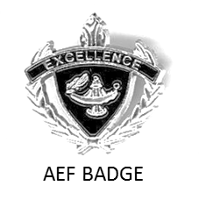



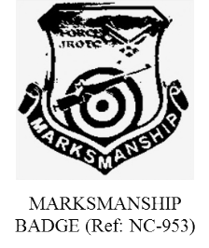
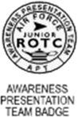
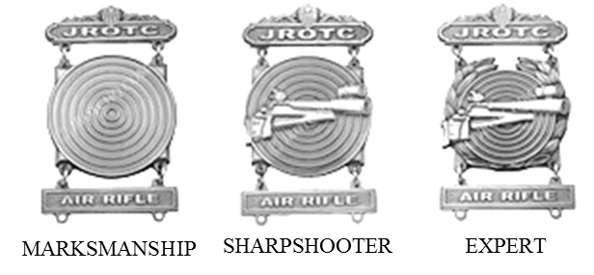

Marksmanship Shield

Choose one only. Follow APT placement criteria.
May NOT wear Marksmanship Shield and a Marksmanship Badge.

Choose one only. Place directly underneath ribbons. May NOT wear Marksmanship Shield and Marksmanship Badge. Do not wear Marksmanship badges with medals.
Attachment 8

AIR FORCE JROTC RANK INSIGNIA

CADET OFFICER RANK

SECOND LIEUTENANT
FIRST LIEUTENANT
CAPTAIN MAJOR LIEUTENANT COLONEL
COLONEL

NOTE: Cadet Officer rank used is either cloth epaulet or collar rank, depending on specific uniform worn.

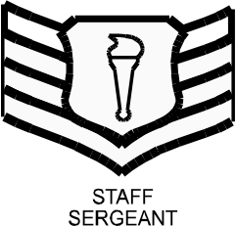
CADET ENLISTED RANK
AIRMAN

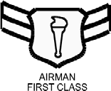
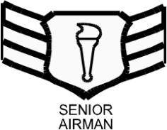
AIRMAN BASIC: NO RANK INSIGNIA

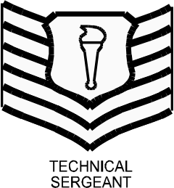
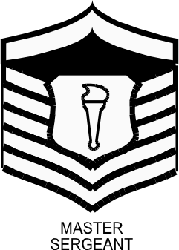
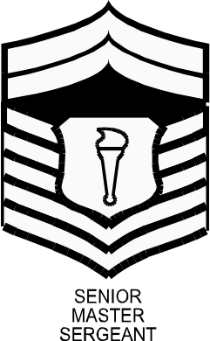
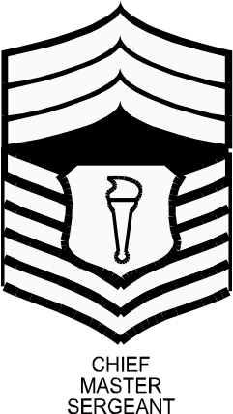

NOTE: Cadet Enlisted rank used is small collar rank only, regardless of uniform worn

Rank insignia not listed here is unauthorized. The First Sergeant device is not authorized.

Attachment 9

CADET MALE HEADGEAR

SERVICE CAP (Officer and Enlisted)

Centered



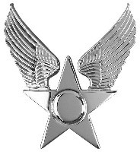
Black hat band

Plain Black

Officer Service Cap may also be worn with the large officer service cap insignia.

FLIGHT CAP* (Officer and Enlisted)


1 ½”
- Enlisted Ranks will have no hat insignia on the flight cap.

- The former officer flight cap emblem will not be worn on the flight cap.

Attachment 10

CADET FEMALE HEADGEAR

SERVICE CAP (Officer Only)
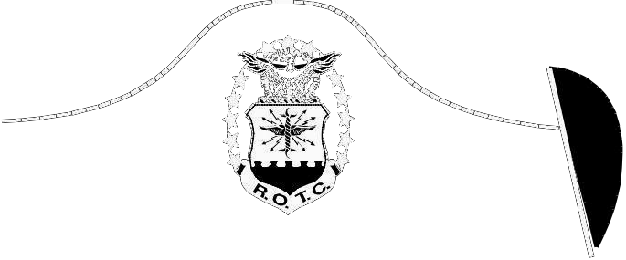
Solid Blue Color with no embroidery
Centered

Enlisted Women’s Service Caps may be worn with the Hap Arnold Wings insignia.

FLIGHT CAP* (Officer and Enlisted)

1 ½”

Enlisted Ranks will have no hat insignia on the flight cap.
- The former officer flight cap emblem will not be worn on the flight cap.
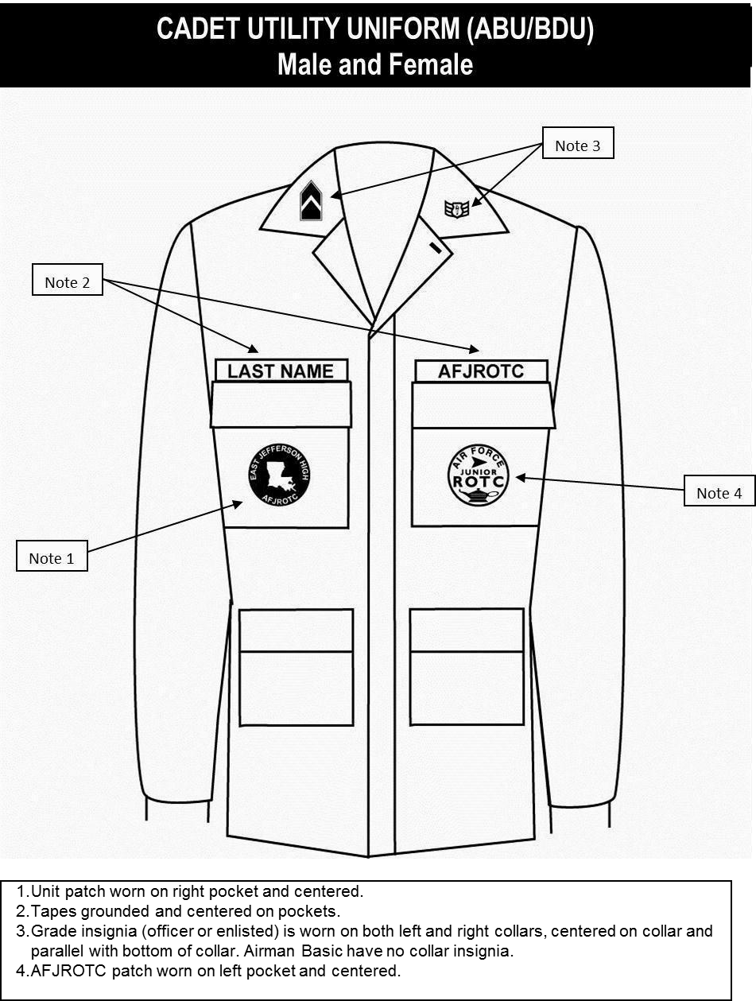
Attachment 11
CADET ABU
Male and Female

- Unit patch (optional). If worn, will be placed on right pocket and centered. (AF Funds may not be used to procure unit patches.)
- Last Name and AFJROTC tapes, dark blue (mandatory). Tapes are grounded and centered on pockets. Name tape only may be held with Velcro to enable reuse/reissue to a different cadet.
- Grade insignia (officer or enlisted) (mandatory). Will be worn on the left and right collars, centered on collar and parallel with bottom of collar. Airman Basic have no collar insignia.
- AFJROTC patch: WHITE patch only (mandatory). Will be worn on left pocket and centered.
Attachment 12
CADET ABU HEADGEAR

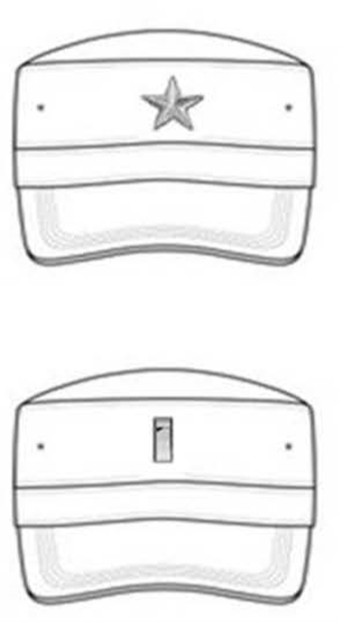

Enlisted Cadets will not wear rank on the ABU cap.
Officers will wear rank insignia on the ABU cap.

Attachment 13
CADET LIGHTWEIGHT BLUE JACKET

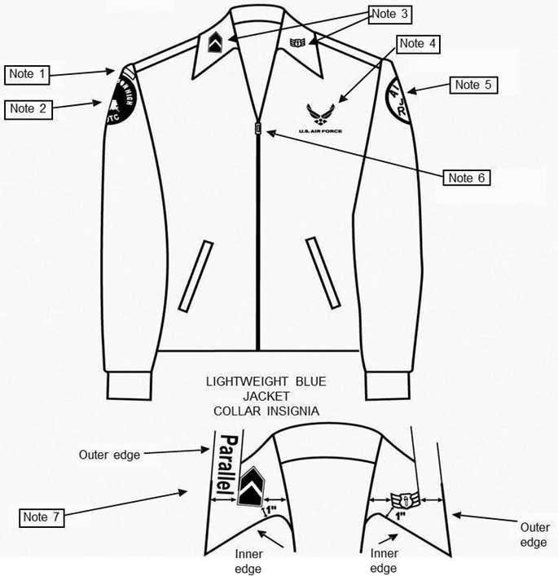
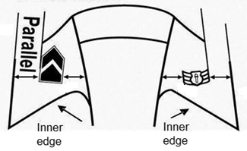
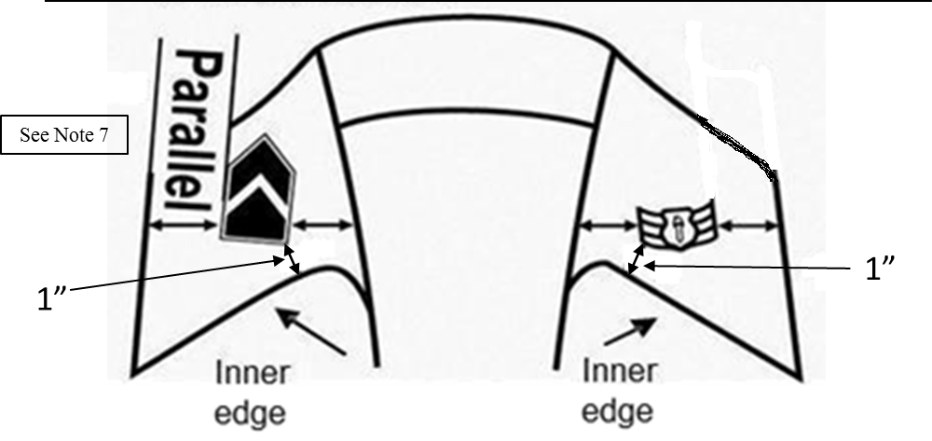
NOTE: The epaulet rank is no longer authorized on the lightweight blue jacket.

Centered halfway

Drawing not to scale
See Note 7

1”
1”

(Picture Not To Scale)

- Shoulder tabs are centered between unit patch and shoulder seam. If no patch, then 1 inch below shoulder seam.
- Unit patch on right ½ to 1 inch below shoulder seam and centered.
- Grade insignia (officer and enlisted) worn on both lapels, mandatory. Place insignia centered halfway up the lapel. Bottom of insignia is horizontal with the ground.
- Optional item: center vertically between the shoulder seam and where the underarm side seam joins the armhole sleeve and center horizontally between the center zipper and the sleeve armhole seam.
- AFJROTC patch on left sleeve ½ to 1 inch below shoulder seam centered.
- Jacket will be closed to at least the halfway point.
- Center insignia horizontally on collar. Place 1 inch from bottom of collar and parallel to the outer edge of the collar.
- Enlisted rank insignia MUST be worn on the blue shirt while wearing the light weight jacket.
Attachment 14
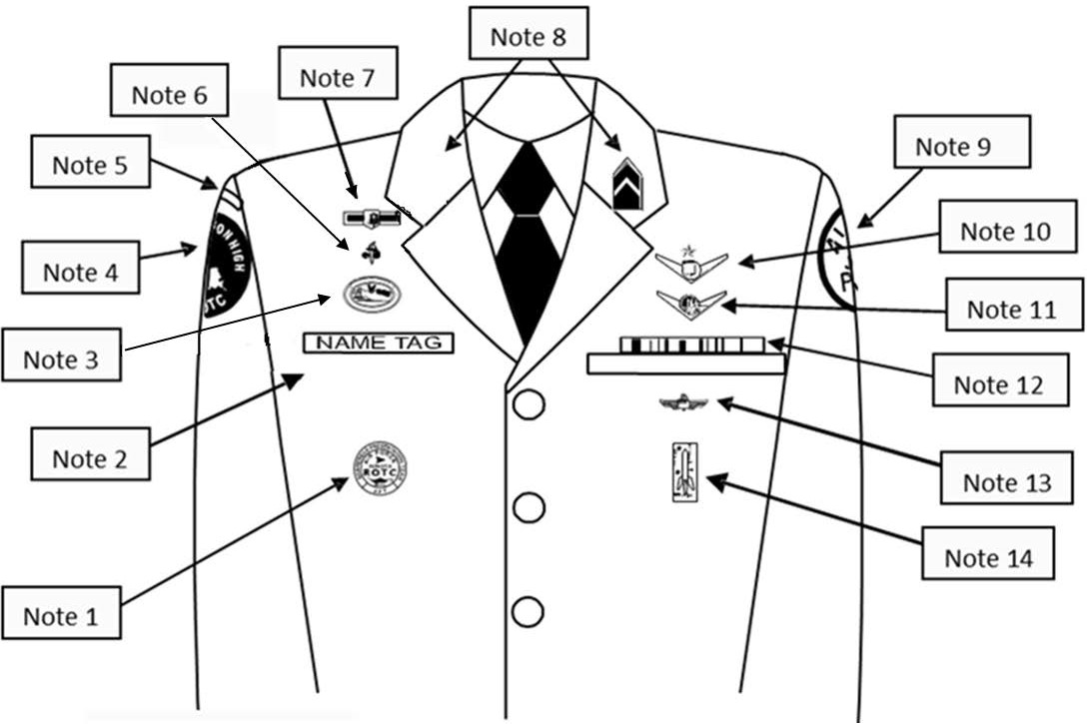



CADET MALE SERVICE DRESS

Note 17
Note 16

- Awareness Presentation Team (APT) Badge. Centered 3 inches below the bottom of the silver name tag.
- Silver Name tag, mandatory. Center on the right side between arm seam and lapel with bottom edge parallel to top of welt pocket.
- Kitty Hawk Badge. See Note 15 below.
- Unit patch. Place ½ to inch below shoulder seam and centered.
- Shoulder tab: Center between unit patch and shoulder seam. If no patch, then 1 inch below shoulder seam.
- Aerospace Education Foundation (AEF) Badge. See Note 15 below.
- Distinguished Cadet Badge. See Note 15 below.
- Grade insignia (officer and enlisted) worn on both lapels, mandatory. Place insignia halfway up the seam, resting on but not over it. Bottom of insignia is horizontal with the ground.
- AFJROTC Patch: Place ½ to 1 inch below shoulder seam and centered.
- Flight Solo or Flight Certificate Badge. See Note 15 below.
- Ground School Badge. See Note 15 below.
- Ribbons, mandatory. Centered, on but not over edge of pocket. Wear 3 or 4 in a row. Wear all or some ribbons earned.
- Academy of Model Aeronautic (AMA) Wings. Worn 1 inch below pocket.
- Model Rocketry Badge. Worn 2 inches below AMA Wings or 3 inches below pocket if no AMA Wings are worn.
- First badge placed ½ inch above silver name tag or ribbons and is centered horizontally. Additional badges are placed ½ inch above previous badge.
- Shoulder Cord. No wider than 1 inch and will be grounded to the seam of the left shoulder.
- Enlisted rank insignia MUST be worn on the blue shirt while wearing the service dress.
- Medals are not authorized for wear on this uniform with ribbons. Ribbons and medals may not be mixed.

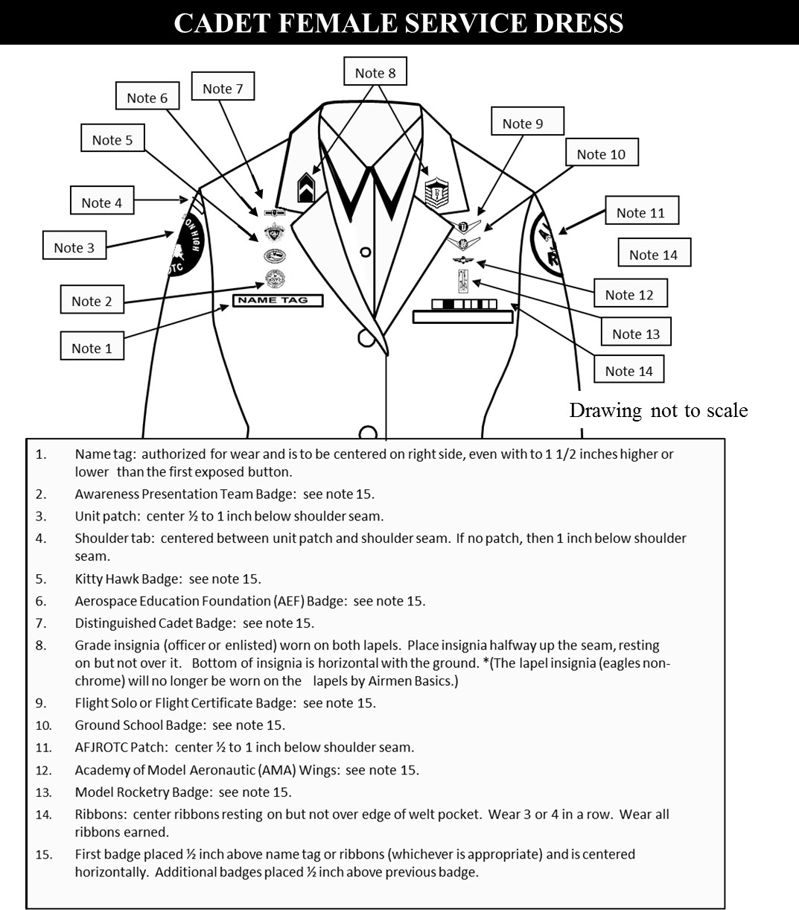

Note 16
Note 17

Silver Name tag, mandatory. Center on the right side between arm seam and lapel with bottom edge even with to 1 ½ inch higher or lower than the first exposed button.
- Awareness Presentation Team Badge. See Note 15 below.
- Unit patch. Center ½ to 1 inch below shoulder seam
- Shoulder tab: Center between unit patch and shoulder seam. If no patch, then 1 inch below shoulder seam
- Kitty Hawk Badge. See Note 15 below.
- Aerospace Education Foundation (AEF) Badge. See Note 15 below.
- Distinguished Cadet Badge. See Note 15 below.
- Grade insignia (officer and enlisted) worn on both lapels, mandatory. Place insignia halfway up the seam, resting on but not over it. Bottom of insignia is horizontal with the ground.
- Flight Solo or Flight Certificate Badge. See Note 15 below.
- Ground School Badge. See Note 15 below.
- AFJROTC Patch, mandatory. Center ½ to 1 inch below shoulder seam.
- Academy of Model Aeronautic (AMA) Wings. Worn 1 inch below pocket.
- Model Rocketry Badge. Worn 2 inches below AMA Wings or 3 inches below pocket if no AMA Wings are worn.
- Ribbons, mandatory. Center ribbons resting on but not over edge of welt pocket. Wear 3 or 4 in a row. Wear all or some ribbons earned.
- First badge placed ½ inch above silver name tag or ribbons and is centered horizontally. Additional badges are placed ½ inch above previous badge.
- Shoulder Cord. No wider than 1 inch and will be grounded to the seam of the left shoulder.
- Enlisted rank insignia MUST be worn on the blue shirt while wearing the service dress.
- Medals are not authorized for wear on this uniform with ribbons. Ribbons and medals may not be mixed.
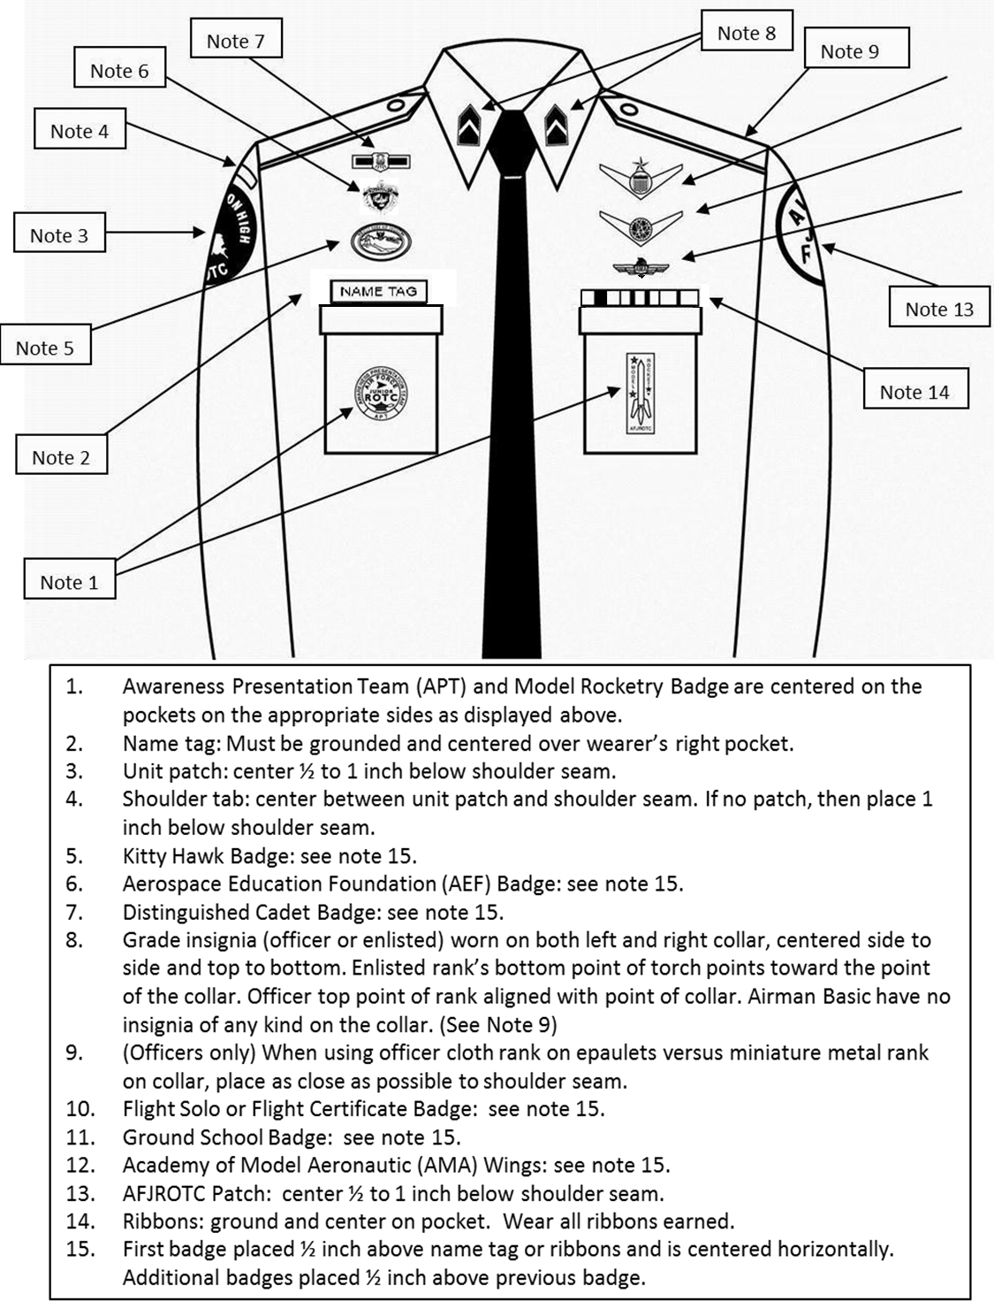


CADET MALE BLUE SHIRT

Note 9
Note 16
Note 10
Note 11
Note 12

  - Awareness Presentation Team (APT) and Model Rocketry Badge are centered on the pockets on the appropriate sides as displayed above.
  - Name Tag: Mandatory wear. Blue Plastic with white letters. Must be grounded and centered over wearer’s right pocket.
  - Unit patch. Centered ½ to 1 inch below the shoulder seam.
  - Shoulder tab. Centered between unit patch and shoulder seam. If no patch, then place 1 inch below shoulder seam.
  - Kitty Hawk Badge. See Note 15.
  - Aerospace Education Foundation (AEF) Badge. See Note 15.
  - Distinguished Cadet Badge. See Note 15.
  - Grade insignia, mandatory (officer and enlisted) worn on both left and right collar, centered side to side and top to bottom. Enlisted rank’s bottom point of torch points towards the point of the collar. Officer top point of rank aligned with point of collar. Cadet/Amn Basic have no insignia of any kind on the collar.
  - Officers only. When using officer cloth rank on epaulets versus miniature metal rank on collar, place as close as possible to shoulder seam. (Use larger male epaulets only).
  - Flight Solo or Flight Certificate Badge. See Note 15.
  - Ground School Badge. See Note 15.
  - Academy of Model Aeronautic (AMA) Wings. See Note 15.
  - AFJROTC Patch, mandatory. Center ½ to 1 inch below shoulder seam.
  - Ribbons are optional. Wear all, some or no ribbons earned. If worn, ribbons will be centered, resting on, but not over the edge of the pleated pocket on the wearers left.
  - First badge placed ½ inch above name tag or ribbons and is centered horizontally. Additional badges placed ½ inch above previous badge.
  - Shoulder Cord. No wider than 1 inch and will be grounded to the seam of the left shoulder under epaulet
  - Medals (regardless of what type) are not authorized for wear on this uniform.
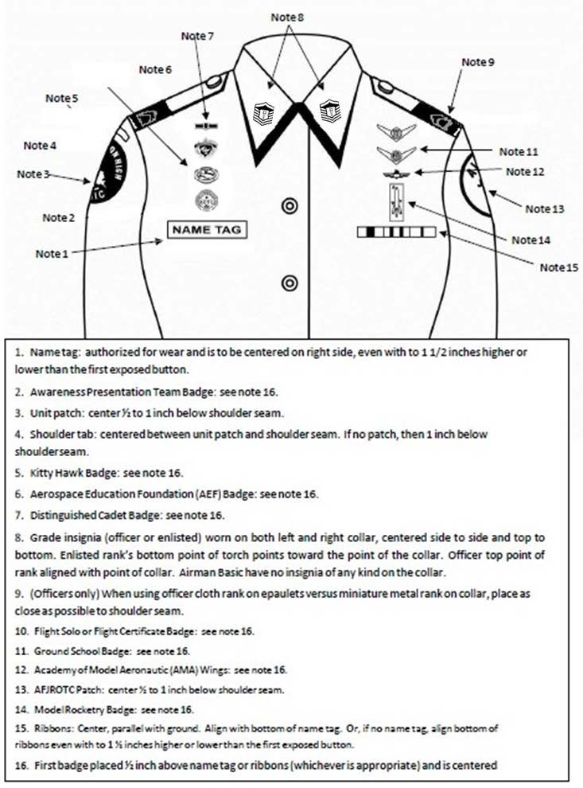
CADET FEMALE BLUE SHIRT

Note 9

Note 17
Note 5

Note 10

    - Name Tag: Mandatory wear. Blue Plastic with white letters. Without ribbons: centered on right side, parallel to ground and within 1 ½ inches higher/lower than topmost exposed button. With Ribbons: Even with bottom row of ribbons, centered on right side, parallel to ground and within 1
½ inches higher/lower than topmost exposed button.
    - Awareness Presentation Team (APT) Badge. See Note 16
    - Unit Patch. Centered on sleeve and ½ to 1 inch below shoulder seam.
    - Shoulder Tab (Metal or cloth). Centered between unit patch and shoulder seam. If no patch, then 1 inch below shoulder seam.
    - Kitty Hawk Air Society Badge. See Note 16.
    - Aerospace Education Foundation (AEF) Badge. See Note 16.
    - Distinguished Cadet Badge. See Note 16.
    - Grade insignia, mandatory (officer and enlisted) worn on both left and right collar, centered side to side and top to bottom. Enlisted rank’s bottom point of torch points towards the point of the collar. Officer top point of rank aligned with point of collar. Cadet/Amn Basic have no insignia of any kind on the collar
    - Officers only. When using officer cloth rank on epaulets versus miniature metal rank on collar, place as close as possible to shoulder seam. (Use smaller female epaulets only)
    - Flight Solo or Flight Certificate Badge. See Note 16.
    - Ground School Badge. See Note 16.
    - Academy of Model Aeronautics (AMA) Wings. See Note 16.
    - AFJROTC Patch, mandatory. Center on sleeve ½ to 1 inch below shoulder seam.
    - Model Rocketry Badge. See Note 16.
    - Ribbons are optional. Wear all, some or no ribbons earned. If worn, center ribbons on wearer’s left, parallel with ground. Align bottom of the ribbons with the bottom of the name tag.
    - First badge is centered ½ inch above name tag or ribbons (as appropriate).
    - Shoulder Cord. No wider than 1 inch and will be grounded to the seam of the left shoulder under the epaulet.
    - Medals (regardless of what type) are not authorized for wear on this uniform.
FLIGHT SUIT (Male and Female)

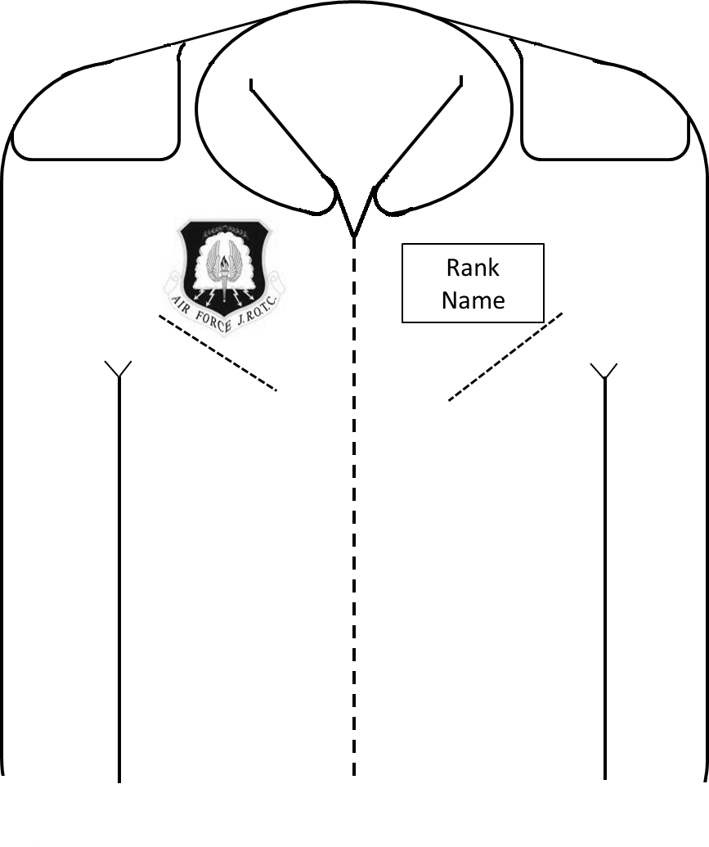


Note 3
Note 2
Note 1
Note 4

- * AFJROTC Command Patch (mandatory). Velcro attached. This style of patch may only be worn on the Flight Suit. Cadets can only wear ground school, flight solo or flight certificate badges upon successful completion those programs (See Ops Supplement, Chapter 7, paras 7.2.1, 7.2.2 and 7.2.3).
- * AFJROTC (white “Lamp of Knowledge”) Patch (mandatory). Velcro attached.
- * American Flag Patch (mandatory). Velcro attached.
- * Cadet Rank and Cadet Name Patch (mandatory). Velcro attached. Black background with silver border/cadet rank/name.
- Flight Suits are authorized for those cadets currently enrolled in or that have successfully completed aviation honors ground school, been awarded a flight solo badge, flight certificate badge or have successfully completed the AFJROTC Flight Academy program.

* Flight patches may be purchased from a vendor using MilPer funds.
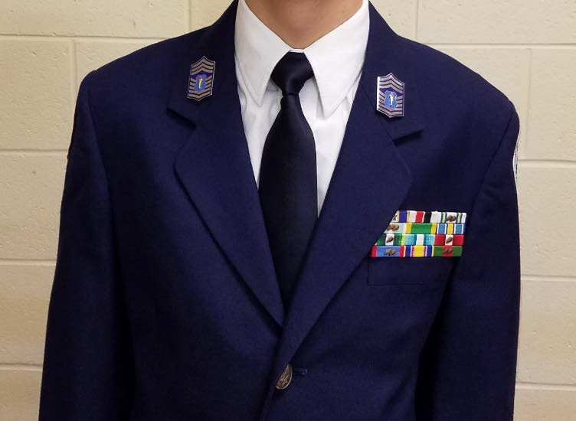
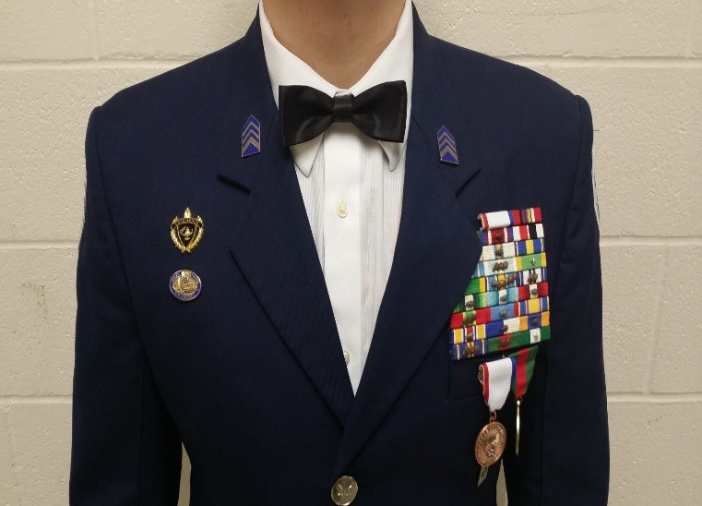
Semi-Formal Dress Uniform
Note 5
Note 4
Note 3
Note 2
Note 1

Note 6

- The blue or white long-sleeve shirt will be plain, knit or woven, commercial type with a short or medium point collar, with button or French cuffs.
- Enlisted members do not need to wear two sets of ranks on the semi-formal uniform.
- The Silver Name Tag will not be worn on the semi-formal dress uniform.
- Black or Blue bow tie may be worn with the semi-formal uniform (white shirt only).
- Ribbons will not be worn on the semi-formal uniform. Large medals may be worn on the Service Dress coat only, directly under ribbon rack.
- Authorized badges may be worn on the semi-form dress uniform. If medals are worn, badges that are normally worn directly under the ribbon rack will not be worn.
- Headgear is not worn with the semi-formal dress uniform.

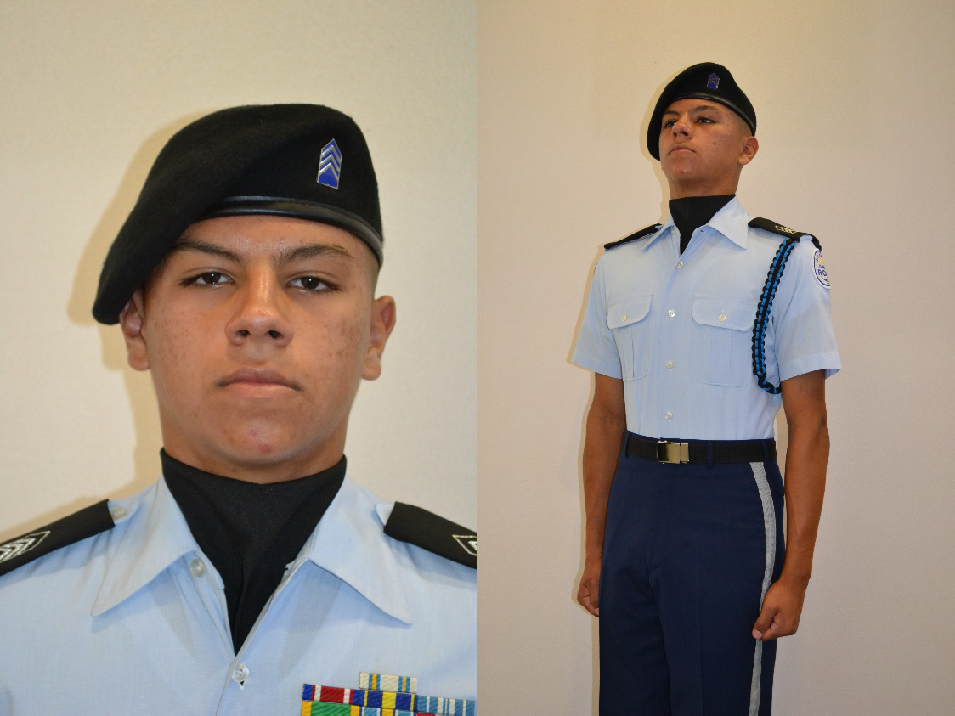
¾ inch stripe

- Berets. Solid Color, white, dark blue and/or black ONLY, with AFJROTC officer and/or enlisted rank insignia and mini-Hap Arnold Insignia. The former officer flight cap emblem will not be worn on the beret.
- Shoulder Cord. Cadets are authorized to wear one shoulder cord on the left shoulder. This will be a single “infantry” style cord, without metal tips, no more than 1-inch wide. On the blue shirt the cord will be under the epaulet, grounded to the left shoulder seam and pinned to the shoulder with the pin hidden beneath the cord.
- Blue/Silver Name Tags and ribbons may be omitted on uniforms where a drill rifle or other equipment may damage the item or injure the performing member. This does not apply to uniforms worn during regular uniform days.
- Blue pants may be modified to have a ¾ inch stripe on the outside length of the pants, silver, dark blue, and/or black only. These items will not be worn on regular uniform days. .
- Solid color ascots may be worn, colors may be locally-determined (school colors), but must be conservative and in good taste, and defined in the Cadet Guide or Unit Operations Instruction. Ascots will not be worn on regular uniform days.
- Embroidery on the Air Force blue drill team uniform is not authorized, i.e., on the back of the blue shirt collar or shoulder yoke.

Specialized unit rank/shoulder boards are not authorized.
- Wrist bands are not authorized.

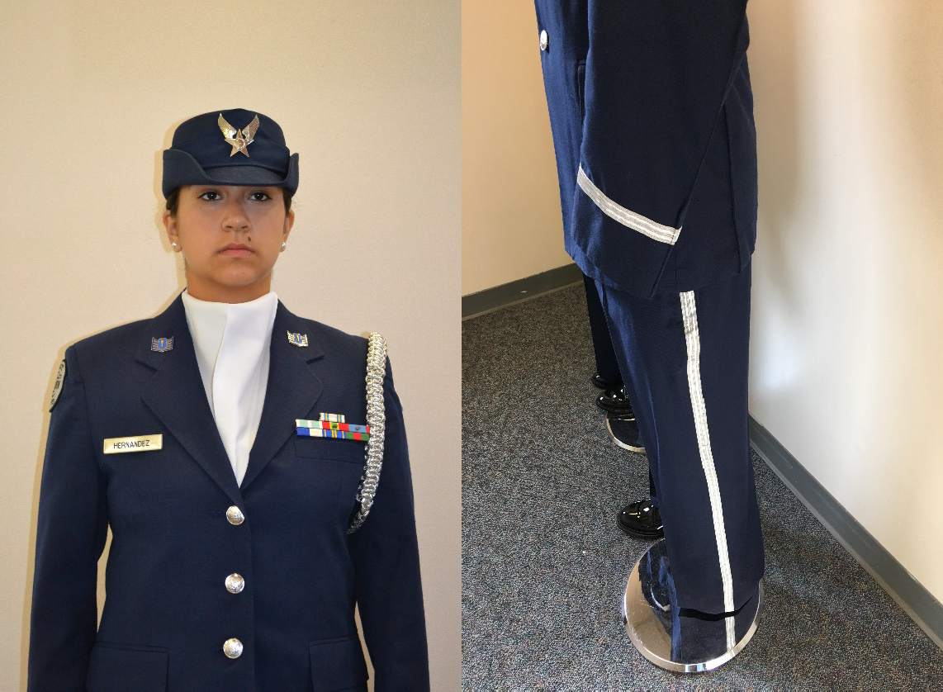
¾ inch stripe

Women’s Service Caps may be worn with the Hap Arnold Wings insignia or Officer Service Cap may also be worn with the large officer service cap insignia large officer’s . Service Caps (wheel and bucket hats) will be a solid color and free of any embroidery.
- Shoulder Cord. Cadets are authorized to wear one shoulder cord on the left shoulder. This will be a single “infantry” style cord, without metal tips, no more than 1-inch wide. On the blue shirt the cord will be under the epaulet, grounded to the left shoulder seam and pinned to the shoulder with the pin hidden beneath the cord. Cords may be any color.
- Blue/Silver Name Tags and ribbons may be omitted on uniforms where a drill rifle or other equipment may damage the item or injure the performing member. This does not apply to uniforms worn during regular uniform days.
- Blue pants may be modified to have a ¾ inch stripe on the outside length of the pants, silver, dark blue, and/or black only. These items will not be worn on regular uniform days. .
- Solid color ascots may be worn, colors may be locally-determined (school colors), but must be conservative and in good taste, and defined in the Cadet Guide or Unit Operations Instruction. Ascots will not be worn on regular uniform days.
- Embroidery on the Air Force blue drill team uniform is not authorized, i.e., on the back of the blue shirt collar or shoulder yoke.

Specialized unit rank/shoulder boards are not authorized.

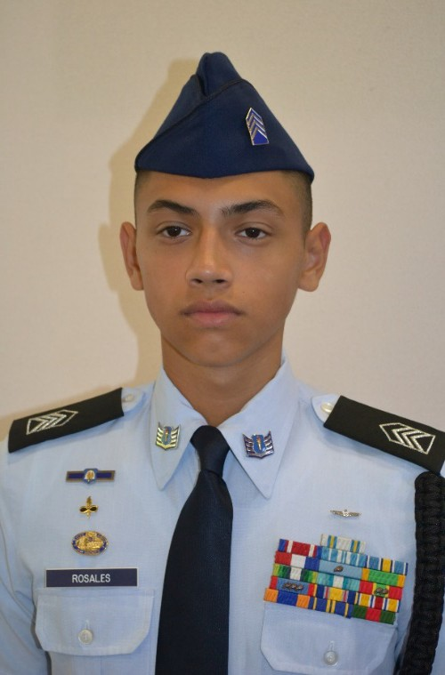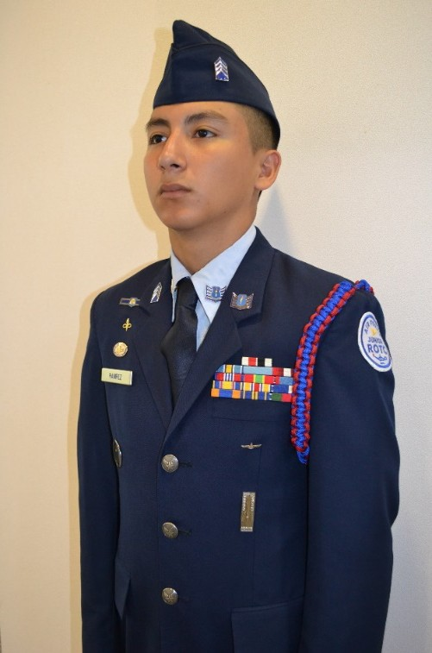

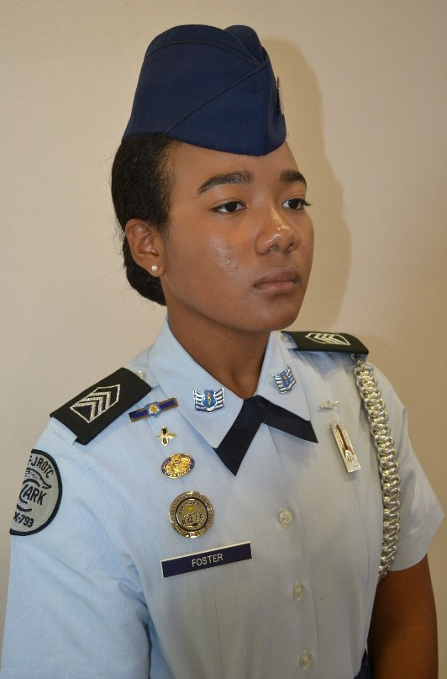


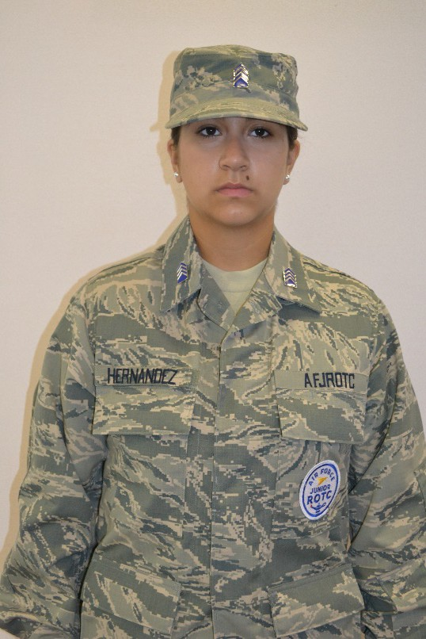
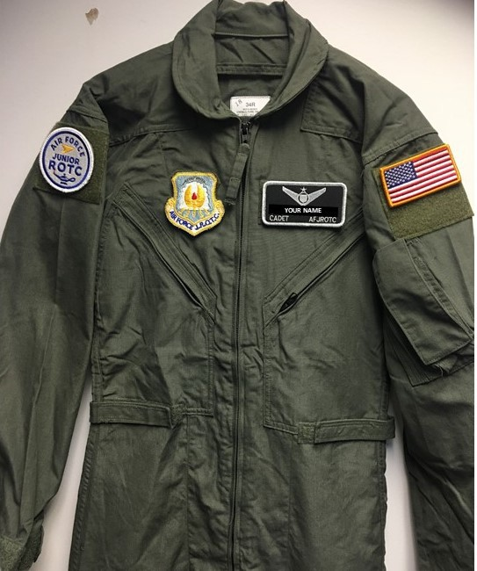

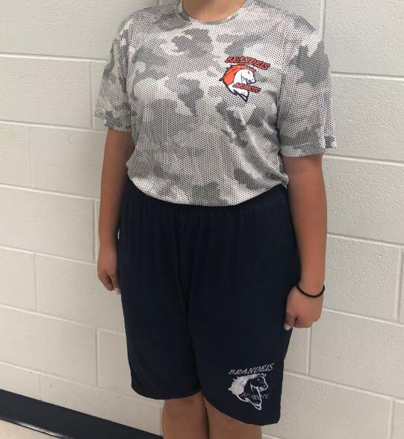
Local Purchased PTG



FEDMALL Purchased Air Force PTG

Windsor Knot (Right)

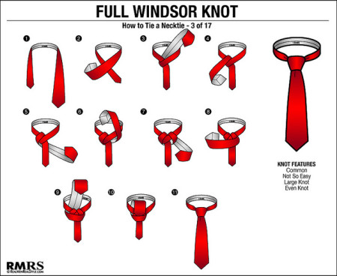

1. With the wide end 12 inches longer than the narrow end
2. Make a loop as shown
3. Bring the wide end around and behind the narrow end
4. Turn the wide end up and put it through the loop of the tie
5. Pull the wide end through and shape carefully
Note: There are several good knot tutorials on YouTube

Four-In-Hand Knot
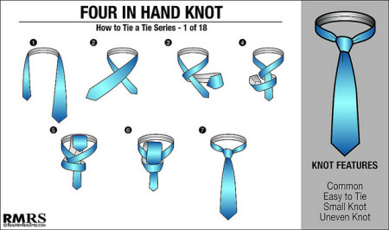

1. With the wide end of the tie on the right side
2. Then cross the wide end over in back and to the left bring it completely around the front to your right
3. Bring it back and up through the center
4. Pass it through the loop in front
5. Tighten the knot neatly, forming a "dimple" with your index finger.
Note: There are several good knot tutorials on YouTube.

Attachment 27

Replacement Price List

Male

Item_____________________________________ Cost
Flight Cap, Male Shade 1620__________________ $10.00
Coat, Service Dress Male Blue 1620____________ $109.32
Jacket, Lightweight Male Blue 1605_____________ $93.00
Shirt, Male Light Blue Short Sleeve Shade 1550___ $17.58
Trousers, Male Blue Shade 1620_______________ $38.74
Belt/Blue__________________________________ $ 6.00
Necktie, Blue Male__________________________ $ 5.70

Female

Item_____________________________________ Cost
Flight Cap, Female Airman Shade 1620__________ $ 8.92
Slacks, Female, Blue Shade 1620_______________ $36.37
Coat, Female Service Dress Blue Shade 1620______ $99.39
Coat, Lightweight Female Blue 1605_____________ $93.00
Blouse, Female Light Blue Short Sleeve Shade 1550_$13.00
Belt/Blue___________________________________ $ 6.00
Tab, Blue Female____________________________ $ 6.00

Miscellaneous Uniform Items

Item_______________________________________ Cost
Ribbons____________________________________ $ 0.75
Ribbon Bars_________________________________Price varies by size
Devices (Oak leaf clusters, stars, etc)______________$ 0.25
Insignia, Flight Cap, Officer_____________________ $ 6.00
Insignia, Rank, Metal, Miniature, Officer __________ $ 7.95
Insignia, Rank, Metal, Large, Officer ______________$12.50
Insignia, Rank, Metal, Airman ___________________$10.00
Rank, Cloth, Officer ___________________________$ 5.00
Name Tag, Blue Plastic________________________ $ 2.00
Uniform Cord/Rope___________________________ $12.00

Note: All are unit prices unless otherwise noted and all prices are subject to change.

Attachment 28

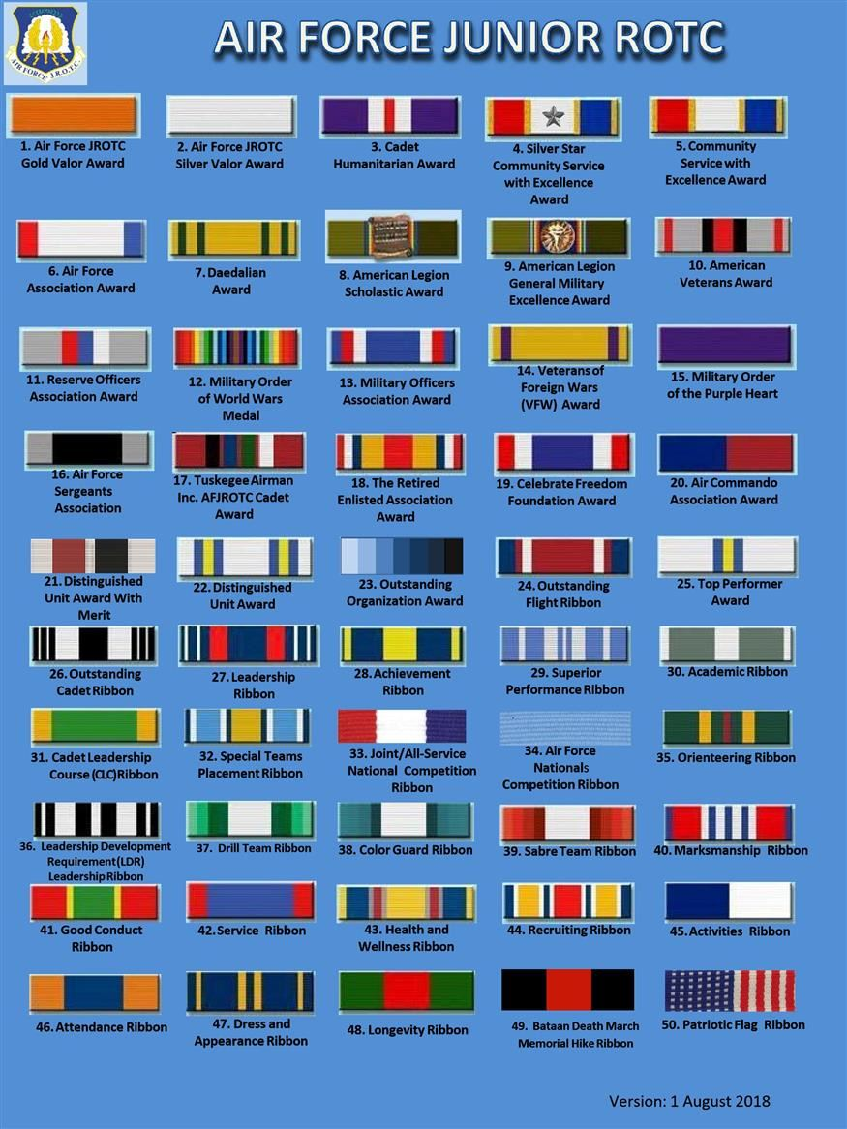

Attachment 29
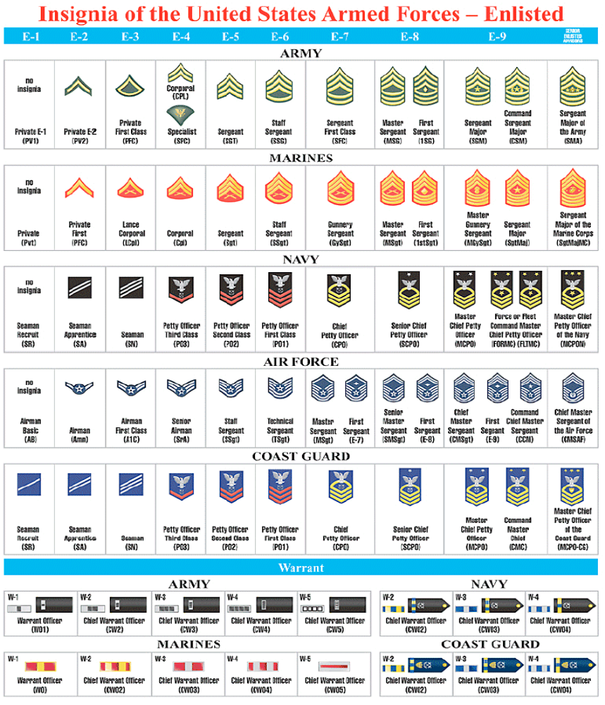

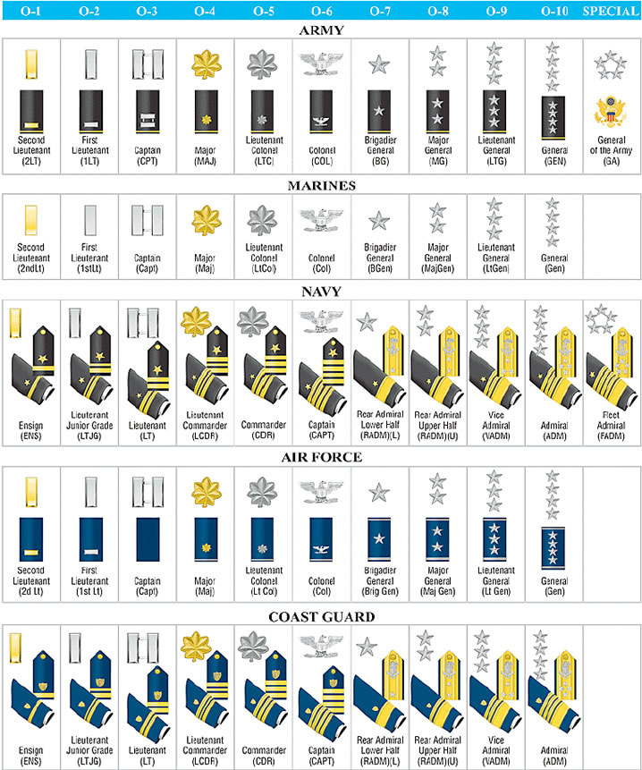
Attachment 30

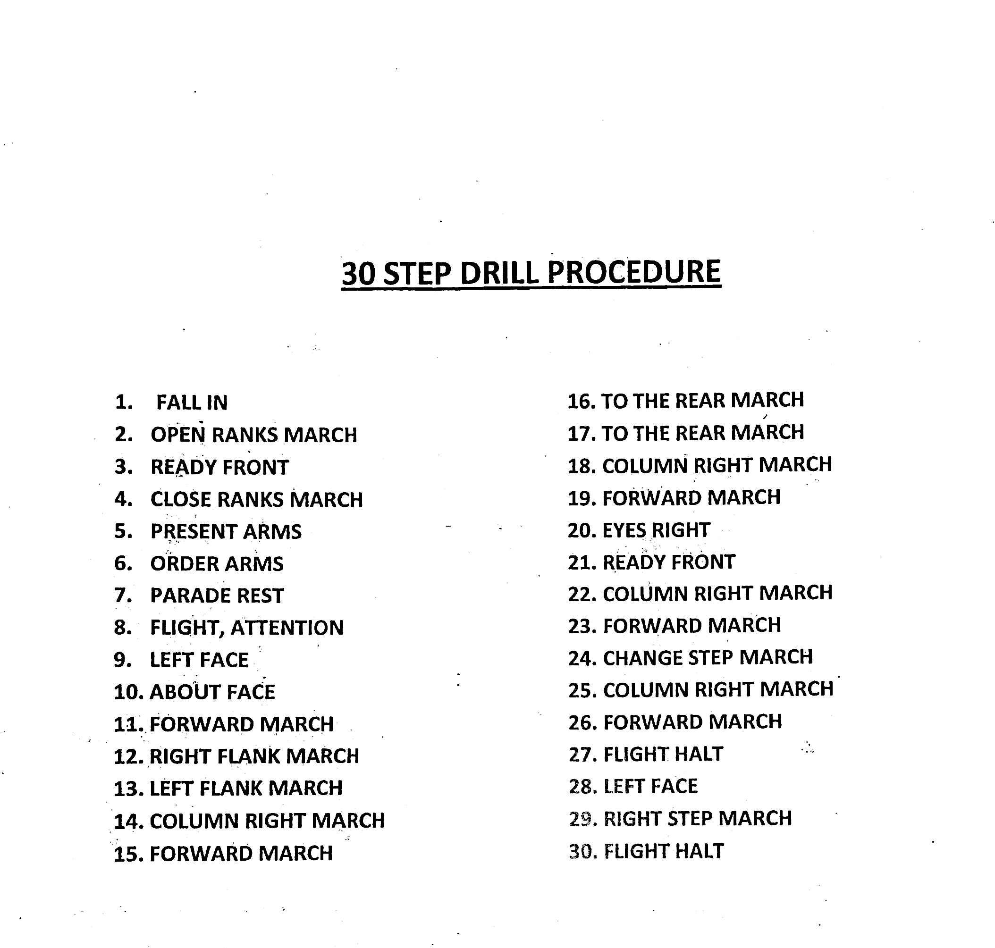
Attachment 31

